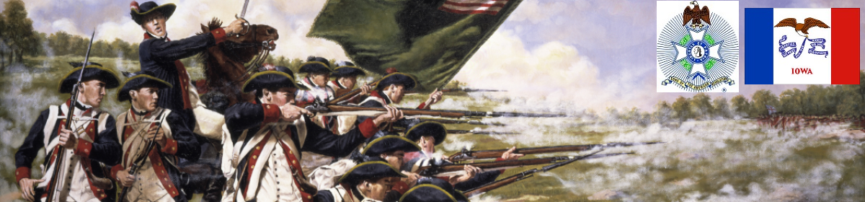

The Iowa Compatriot
The Journal of the Iowa Society, Sons of the American Revolution February 2, 2018

We the descendants of the heroes of the American Revolution, who by their sacrifice established the United States of America, reaffirm our faith in the principles of liberty and solemnly pledge to defend them against every foe.

20 Questions: Test your citizenship knowledge. No cheating!
http://features.desmoinesregister.com/news/education-civics-test/

*****************************************************************************************************************************
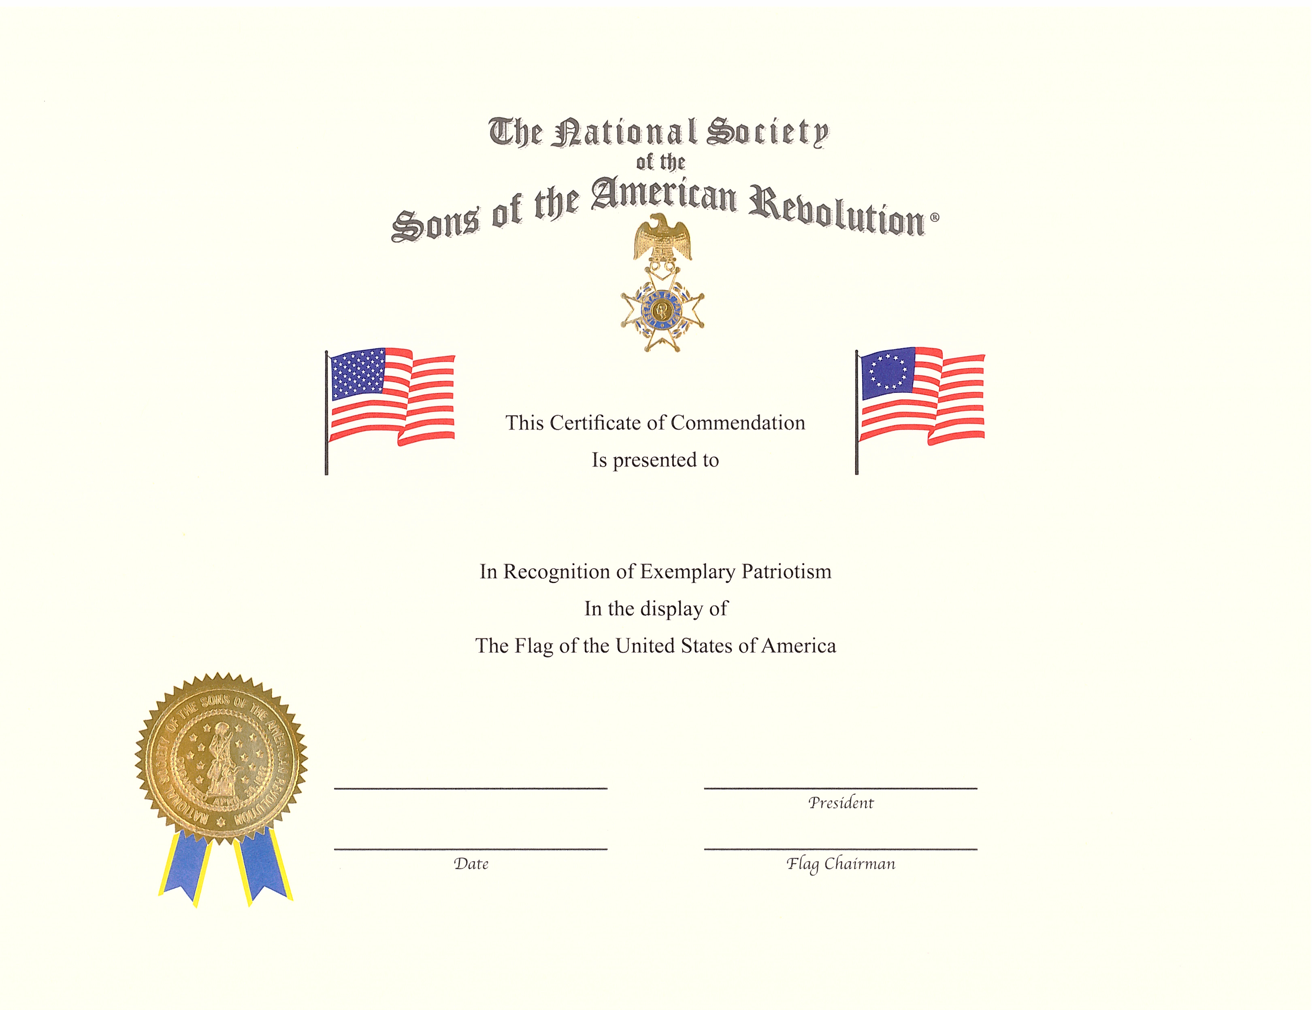
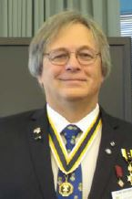

Admiral William R. Furlong Award – a request from Iowa S.A.R. President Alan Wenger

We have these certificates available. Do we have any members willing to present them to deserving recipients that are proudly flying the flag correctly in their hometown? If so let us know.

State Presidents,

The new year is upon us and there is still plenty of time for your society to have 100% of your chapters present flag certificates.

If over one-half of your state chapters and the state society present flag certificates that will qualify for the Furlong Award.

If 100% of your chapters and the state society presents flag certificates your society will receive a Certificate of Excellence in addition to the Furlong Award.

The Furlong Award is a banner to fly on your flag staff and a certificate. If your society has already received the banner then you will receive a white star to place on the banner.

It’s time to encourage your chapters to present flag certificates. This is an excellent say to obtain publicity for your chapters, your state and the national society.

Jim Alexander
NSSAR Flag Committee Chairman

Compatriot David Lamb Recounts Service of
Patriot Sarah Hartwell Shattuck

O
n 15 December 2017 the Iowa Society had its first members ever approved (Ronald, Mark and Alan Hughes) through the service of a woman patriot, Mary/Polly (Hawkins) Craig.

Below is a story of yet another potential Revolutionary War Patriot, Lt. Sarah Hartwell Chattuck, the 5th great-grandmother of Iowa Society member David M. Lamb.

Lt. Sarah Hartwell Shattuck, 1738-1798
Massachusetts “Minute-woman”
Of
“The Company of Prudence Wright’s Guard”
1775
Sometimes, it seems, a girl’s just gotta do what she’s gotta do.

We’re all pretty much familiar with the story of “The Midnight Ride of Paul Revere” thanks to the poetry of Henry Wadsworth Longfellow…but fewer of us, I suspect, are familiar with the “rest of the story” (with apologies to Paul Harvey).

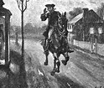

When Revere, Prescott and Dawes spread the word that British troops had departed Boston for the environs of Concord and Lexington on the night of April 18th, 1775, local militia units from all over that part of Massachusetts picked up their best muskets, powder horns and shot and headed for pre-determined rallying points that would place them in positions to confront the on-coming King’s Grenadiers. The Company of Col. William Prescott of Pepperell was no exception. Both David Wright of Pepperell, and Job Shattuck of Groton bid their respective families farewell, and marched off to encounter their destinies, leaving their wives, children and aged parents behind.

When news of the skirmishes at both Lexington and Concord began to filter back through the Massachusetts countryside in the days immediately following the “shot heard around the world”, groups of the women who had been left behind began to gather at one another’s homes and on the village greens of the small farming communities along the course of the Nashua river; and, earnestly air their concerns that the main “highway” between British Canada and the British garrisons at and around Boston were likely routes for local Tories and other Royalist to be sending messages that might prove counter-productive to the fates of their absent citizen-soldier husbands, sons, brothers and fathers.

Clearly…something needed doing.

About midway betwixt the hamlets of Groton and Pepperell was a bridge that the local ladies considered to be in need of “defending”. Led by Mrs. David (Prudence Cuming) Wright and her friend, Mrs. Job (Sarah Hartwell) Shattuck, the ladies of the vicinity decided that they would don their absent husbands, fathers, brothers, and sons, clothing and pick up their “second-best” muskets, and powder horns and post sentries at the bridge (now known as “Jewett’s Bridge”) and a more magnificent structure now than it was then.
The “Company” (estimated to number between thirty and forty women in strength) quickly elected Prudence Wright to be their “Captain”; and Sarah Shattuck to be her Lieutenant, and Second in Command.

The thought being that if local Royalist sympathizers, or Tories were to attempt mischief; or, if British soldiers should show up in the vicinity, they might be intimidated into retreating until word could be sent to the closest militia units that they were needed.

A couple versions of the story of what would become known as, “The Prudence Wright Guard” emerged in the years following the war and have been reproduced below:
The earliest version of the story comes from the book History of the Town of Groton, published in 1848, which states:

“After the departure of Col. William Prescott’s regiment of ‘minute men,’ Mrs. David Wright of Pepperell, Mrs. Job Shattuck of Groton, and the neighboring women, collected at what is now Jewett’s bridge, over the Nashua, between Pepperell and Groton, clothed in their absent husbands’ apparel, and armed with muskets, pitchforks, and such other weapons as they could find, and having elected Mrs. Wright their commander, resolutely determined, that no foe to freedom, foreign or domestic, should pass that bridge. For rumors were rife, that the regulars were approaching, and frightful stories of slaughter flew rapidly from place to place and from house to house. Soon there appeared one on horseback, supposed to be treasonably engaged in conveying intelligence to the enemy. By the implicit command of Sergeant Wright, he is immediately arrested, unhorsed, searched, and the treasonable correspondence found concealed in his boots. He was detained prisoner and sent to Oliver Prescott, Esq., of Groton, and his despatches were sent to the Committee of Safety.”

Decades later, in 1899, Mary L. P. Shattuck gave a speech, at the Pepperell chapter of the Daughters of the American Revolution, during which she presented two versions of the story collected from the descendants of Leonard Whiting and Prudence Wright:

“The report of the fight on Lexington Green and at Concord came to the town later. The women knew that their townsmen had helped chase the British and were now with ‘other minute men’ near Boston, and that more serious action was imminent. Spies were reported as passing between the British in Canada and those in Boston. One direct road from Canada to Boston ran through Pepperell.
For the women there was all the anxiety and dread uncertainty with none of the excitement of the assembled forces nearer Boston, but when they knew there was a possibility of doing something they seized the opportunity, and in the spirit that animated the ‘minute men,’ acted at once. Word was sent from house to house in Pepperell, for the women to assemble. We know that some from Groton also responded. Hollis women may have been represented in the gathering. They determined that no foe to the cause so dear to them should pass through town, if they could prevent it. They elected Mrs. David Wright, (Prudence Cumings Wright) as commander of their company. She chose Mrs. Job Shattuck, (Sarah Hartwell Shattuck) of Groton, as her lieutenant….

Unfortunately, the muster roll of the ‘Guard,’ if one was made, was not preserved. Tradition enrolls the women of this immediate neighborhood, between thirty and forty in number. We know that their uniform was their absent husbands’ and brothers’ clothing, and their accoutrements were the muskets left by the men pitchforks and anything that could be made to do service.

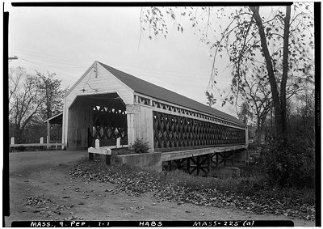
Nehemiah Jewett bridge, photographed by Frank O. Branzetti for the Historic American Buildings Survey, Oct. 17, 1940

Their rendezvous was Jewett’s bridge over the Nashua River, in Pepperell, the place where a person coming from the north would be obliged to cross, unless he forded the river. The ‘Guard’ assembled at dark one night a few days after the nineteenth of April, when they heard the rumor that British messengers were expected to cross the town. There were pine trees on one side of the river near the bridge, but no houses very near. The bridge at that time was an open one. The road, then as now, curved around high land on the north side so that the bridge was not visible until it was nearly reached by a person coming from the north.
How long the women waited there was not remembered by our grandmothers in their story, but they were excited, so the story runs, as told by a descendant of Leonard Whiting, for when two horsemen approached from the north they heard the women’s voices before they came in sight, and the captain’s voice above the others. One of the horsemen recognized it as that of his sister, whose fearless, determined spirit he knew full well.

‘Not one further step I ride!
One who rode with Whiting cried
‘Tis my sister Prue! Alas,
She would never let me pass
Save when her dead body fell!
I turn back from Pepperell.’ – poem by Annie V. Cuthbertson,
published in “Turner’s Public Spirit” of January 15, 1898, Ayer, Mass.

And, from that hour, her brother Thomas was never seen by his family or townsmen, so this tradition runs. Capt. Whiting being a military man, was not so much impressed by the voices of the women, and rode on into the midst of the ‘Guard’ before he realized the nature of the force he had to face.
The women surrounded him, seized his horse, and at the command of ‘Capt. Wright,’ compelled him to dismount and submit to search. In his boots were found treasonable papers. The women marched their prisoner to the middle of the town, probably up Main street to the tavern kept by one Solomon Rogers. They were entertained a substantial supper no doubt and guarded their prisoner until morning, when they marched him to Groton and delivered him into custody. The papers were sent to the committee of safety at Charlestown.

Here is a slightly different version of the story as told by a descendant of David and Prudence: Soon after her son Liberty died, Prudence went to her Hollis home, and one afternoon heard her brother Samuel, and Leonard Whiting make plans to meet a force of English and lead them to Groton. She succeeded in leaving Hollis without exciting their suspicion and returned to Pepperell, where she called together the women, who dressed in their absent husband’s clothing and proceeded to the bridge near Jewett’s fordway, prepared to defend it in the absence of their husbands and brothers.

Soon after nightfall, horses were heard approaching, but instead of the force of British expected, only two horse men approached. Prudence, as chosen leader, ordered a halt. They turned to fly, but the women seized their horses. Leonard Whiting drew his revolver and was about to use it when Samuel Cumings made him lower it, saying: ‘I recognize Prude’s voice and she would wade through blood for the rebel cause.’ The men were dismounted and searched, and despatches from the British forces in the field, to the British General in Boston were found upon them.

The prisoners were taken to Groton to the committee of safety, and the next day were given their liberty on condition that they would leave the colony. They departed in the direction of New York. Samuel Cumings never returned. Samuel was the favorite brother of Prudence, and his loss was a life-long grief to her. At the time when Leonard Whiting was delivered into the custody of Dr. Oliver Prescott, a member of the committee of safety in Groton, his daughter Annie was twelve years old, and the doctor’s son Oliver, of the same age. Some years later she became the wife of Dr. Oliver Prescott, Jr., who built for his bride the Jacobs house in Groton, where they lived until they removed to Newburyport.”

It is not clear if the two men arrested that night ever served time for their alleged crimes and there is no definitive proof that the documents they were carrying were indeed “treasonable papers.”

According to the book, “History of the Town of Hollis”, the men, and many of their associates, were deemed suspicious numerous times in the months that followed but were eventually cleared of any wrongdoing due to a lack of evidence. When Thomas Cummings was indicted on a new charge shortly after, he fled the country with his brother Samuel and Leonard Whiting’s brother, Benjamin, following shortly behind. Their estates were later confiscated and they all died in exile.

The Daughters of the American Revolution have a chapter in Massachusetts named for Prudence Cumings Wright. At the gravesite of Sarah Hartwell Shattuck in the “Old Common Bury” at Groton is a plaque placed by the same D.A.R. chapter honoring her service to our nation in the earliest days of the American Revolutionary War. It reads:

“Sarah Hartwell Shattuck
Lieut, Company of Women
Who Captured a Tory Carrying
Dispatches to British Army, Boston,
1775”
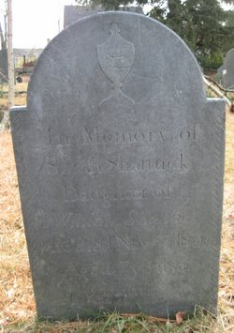
Grave of Sarah Hartwell Shattuck, “Old Common Bury”, Groton, Mass.
Captain Job Shattuck was my fifth Great-grandfather; and his erstwhile Goodwife Sarah (aka Lt. Sarah Hartwell Shattuck) was my fifth Great-grandmother.
David M. Lamb, Iowa Society, Sons of the American Revolution

Have you looked at the IASSAR Website Lately? Stay up-to-date with all IASSAR activities. www.iassar.org

Contribute to The Iowa Compatriot!
This is your newsletter, covering all activities and programs of the IASSAR. To keep it alive and vibrant, we need you to contribute stories about SAR events happening in your part of the state. The stories need not be long. However, they do need to reflect the ideals of the SAR, and how our Iowa compatriots support them. Sharing what we do will help unify our membership. Please send your stories to me. We’d love to print your photos as well! My email address is dlfrazer@yahoo.com. If you would prefer to use the USPS to mail your news items and photos, address them to me at:

Doug Frazer, 4410 Skyline Drive, Des Moines, IA 50310

Your IASSAR Board of Managers

President Alan Wenger awenger5@mchsi.com
1st V.P Mike Rowley MJR1825@gmail.com
2nd V.P. Kevin Parmenter mail@parmenter.com
Secretary George DeMoss geodemoss62@gmail.com
Treasurer George DeMoss geodemoss62@gmail.com
Acting Registrar Alan Wenger awenger5@mchsi.com
Chancellor Lance Ehmcke Lance.Ehmcke@heidmanlaw.com
Historian Doug Frazer dlfrazer@yahoo.com
Eagle Scout Chr. Doug Frazer dlfrazer@yahoo.com
Webmaster Patrick Lant iassarwebsite@gmail.com

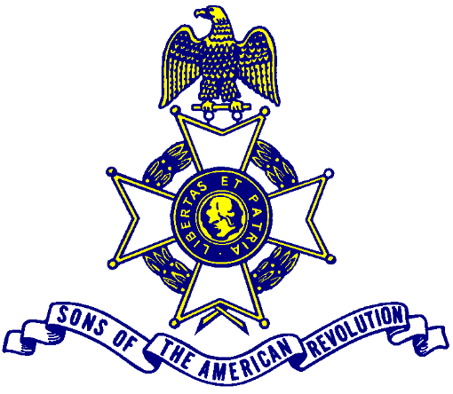

Let us remember our obligation to our forefathers, who gave us our Constitution,
The Bill of Rights, an independent Supreme Court and a nation of free men.

