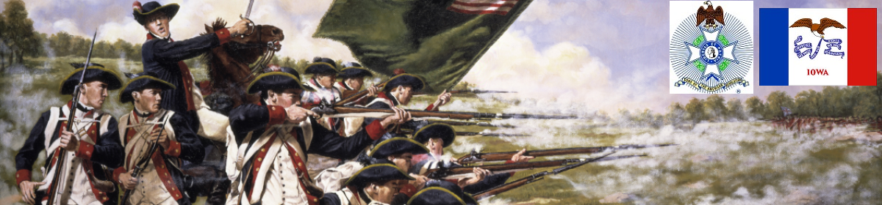

The Iowa Compatriot
The Journal of the Iowa Society, Sons of the American Revolution July 6, 2017
________________________________________________

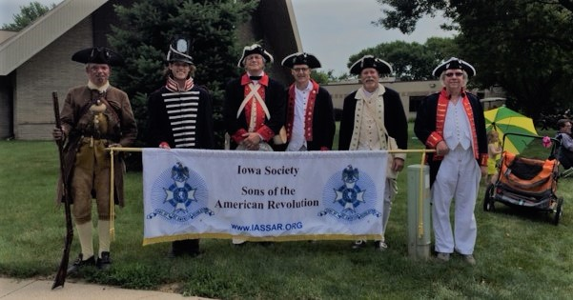
IASSAR Honors American Independence

America celebrated her 241st birthday with the encouragement and assistance of members of the Iowa SAR and General Society of the War of 1812 in the State of Iowa Color Guard, members and friends.

As has been the tradition for many years the festivities started with participation in the Urbandale (Iowa) Parade. Some have suggested (and few have disputed) that this is likely the most attended 4th of July Parade in the State of Iowa.

This year as in years past we joined with the DAR and CAR. David Lynch serenaded all with his beautiful selection and performance of musical favorites.

Our Patriots were led by motivator, educator and historian Tom Clegg who as usual encouraged, inspired, educated and engaged the throngs of attendees (in his period correct clothing and weapon) lining the roughly 2 mile walk.

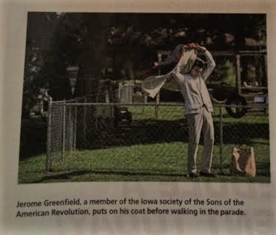
While some of our more senior members and veterans David Lamb and Ron Rittel represented both the GSW 1812 & the SAR on the Urbandale American Legion float, members Dr. Jerry Greenfield, Jon Verner, David Rowley, IASSAR President Alan Wenger and Mike Rowley marched and carried the banner in uniform.

Of special note was the moment of silence and recognition by the color guard in respect and remembrance of Urbandale Police Officer Justin Martin of the Urbandale Police Department at the location where the officer was slain in November of 2016.

While the high temperatures and humidity tested those of us dressed in wool, it did nothing to dampen the enthusiasm, respect and gratefulness of the crowd.

~Mike Rowley, IASSAR Vice President

The top photo shows from left to right, Tom Clegg, David Rowley, Alan Wenger, Jerry Greenfield, Mike Rowley and Jon Verner.

Volunteers Pitch In to Clean Up Glendale Cemetery
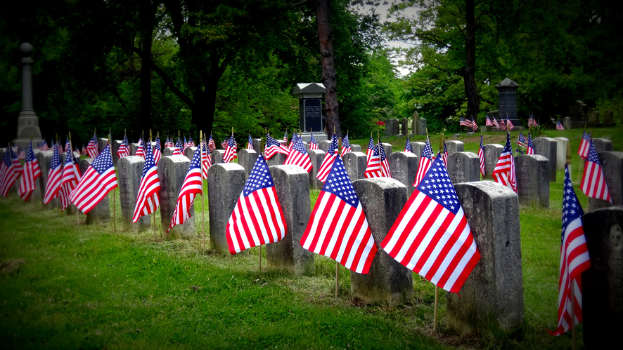
Volunteers came (to Glendale Cemetery, Des Moines, Iowa) on July 5 to gather flags and collect cemetery decorations. We had help from another group at the cemetery, all young guys, eager to help. We walked the veterans burial area on the west side, some 3000 graves. Everybody was hot and ready to get home and hit the shower.

~George DeMoss, IASSAR Secretary/Treasurer

Spring Conference Hosts Eagle Scout and C.A.R.’s Puppy Jake Foundation Project

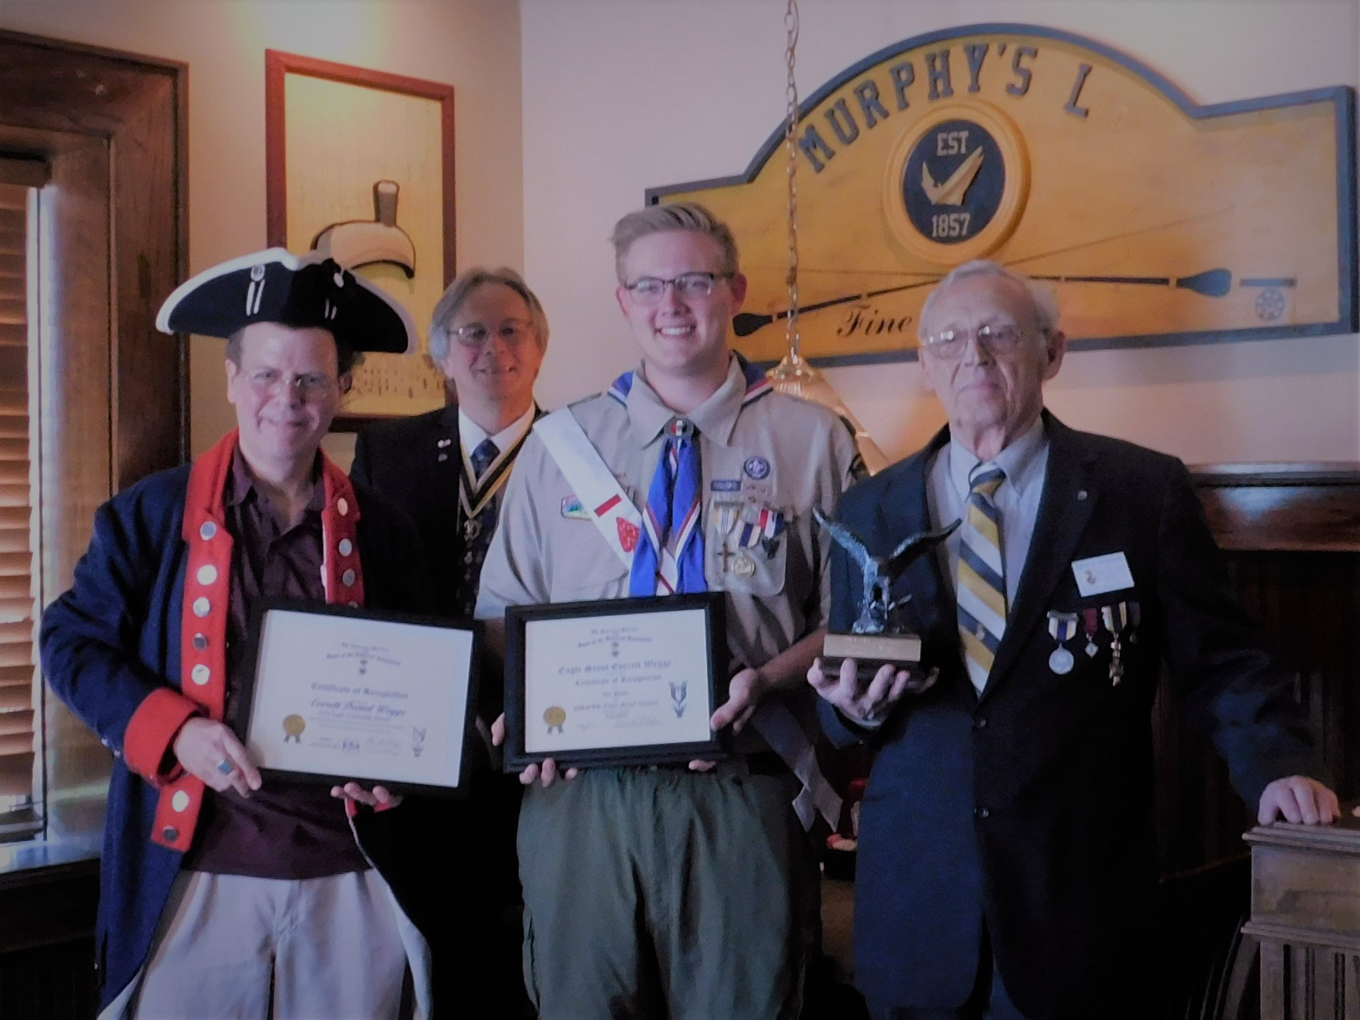
Here are some photos from the June 10th Iowa S.A.R Spring Conference. Two of the photos are of the Arthur M. and Berdena King Eagle Scout Award winner from Iowa, Everett Wegge (who placed 3rd nationally); (L-R): Dr. Doug Frazer, current Eagle Scout Program Coordinator and Committee Chairman, Iowa S.A.R State President Alan M. Wenger, Everett Wegge, winner, and David Shannon, recently retired Eagle Scout Program Coordinator and Committee Chairman. David laid the groundwork for Mr. Wegge to compete in the contest.
The other photo is of incoming 2017-2018 C.A.R. State President, David Franks and President Alan M. Wenger. Mr. Franks State Project for his coming term is to raise funds for the Puppy Jake Foundation. This is an Iowa based program to train and provide companion dogs to veterans who suffer from Post-Traumatic Stress Disorder (PTSD). Mr. Franks father is currently active military, so this project holds special meaning for him.

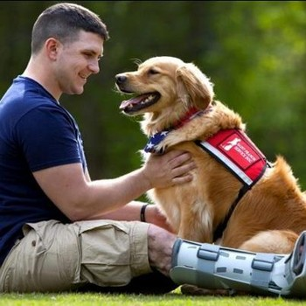
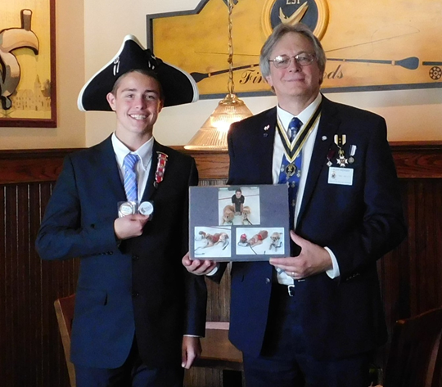

~Alan M. Wenger, IASSAR President

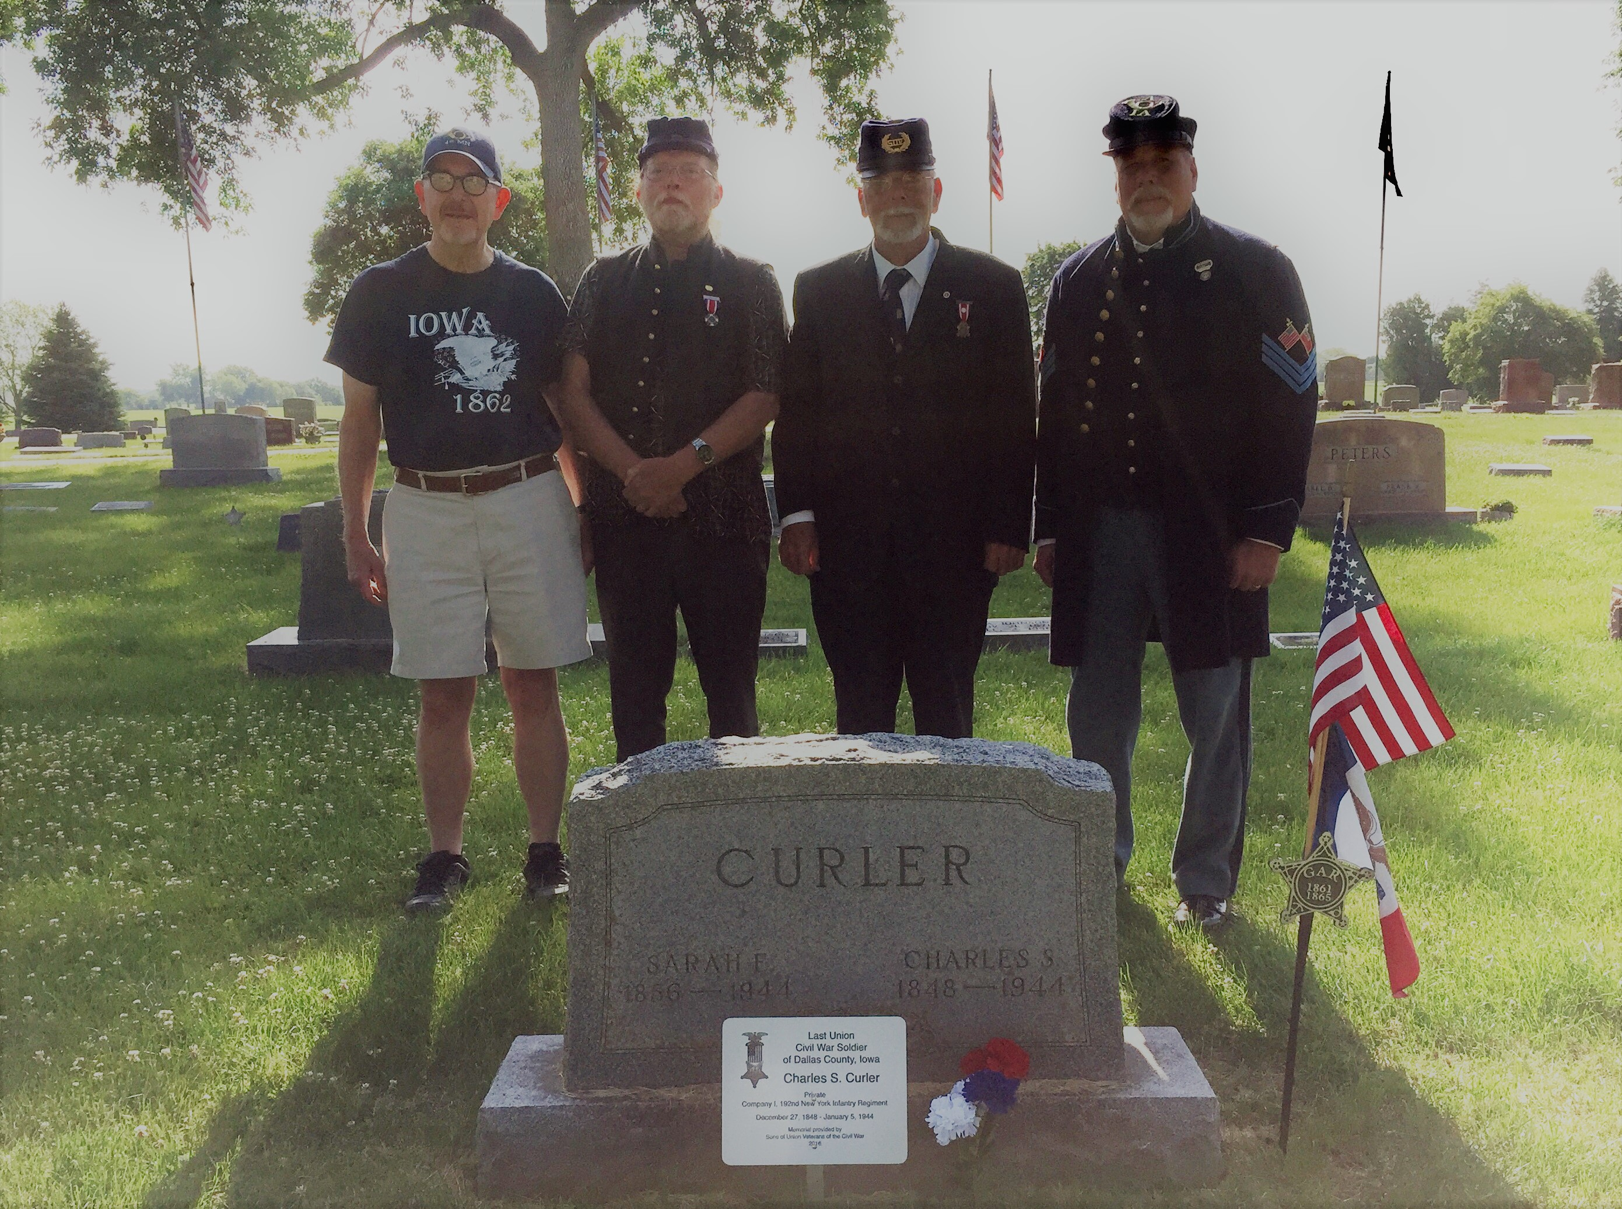

Civil War Union Veterans Graves Marked
On June 4, 2017 4 members of the Iowa Society of the Sons of the American Revolution, Tom Gaard , Danny Krock, Ron Rittel and Mike Rowley joined with SUVCW member Dan Rittel and WRC members Marilyn Rittel and Tammy Krock to mark the graves of the last Civil War Union Veterans to die in 7 Iowa counties.

1. Perry. Charles Curler - last soldier of Dallas County. Violet Hill Cemetery.
2. Earlham. Aaron Cleveland - last soldier of Madison County.
3.Winterset. Chester Dickenson - last soldier of Union County.
4. Indianola. Charles Hester - last soldier of Warren County.
5. Gosport. Robert Millen is last soldier of Marion County.
6. Oskaloosa. Harvey Bloomfield - last soldier of Monroe County.
7. University Park. Henry White - last soldier of Mahaska County.

Ron Rittel's research on all 100 (yes there is a story as to why 100 not 99) last surviving Union veteran in each of Iowa's 99 counties can be seen at ...

iowa_last_soldier_project_ver_-_06.28.2013.pdf

Also, special thanks to Tom Gaard for helping fund the plaques placed by Dodge Camp SUVCW members.
~Mike Rowley
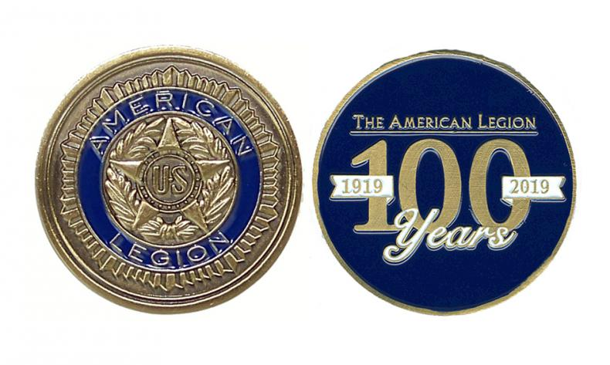

American Legion Coin - Your Help Needed
The American Legion is working toward a commemorative coin for its 100th Anniversary. This coin would be struck by the US Mint and would be not only commemorate the 100th Anniversary, but also a fundraiser to help pay for the activities surrounding the celebration.

In order for the mint to strike the coin, authorization must be given by the US Congress. A maximum of two coins are struck each year. Right now, the two choices for the next coin are The American Legion and the NBA Hall of Fame. We need all of our Senators and Representatives to sign as co-sponsors of the legislation to authorize the coin. That has happened in the House but in the Senate, neither Sen. Grassley nor Sen. Ernst have put their name on the legislation. WE NEED YOUR HELP WITH THAT.

Please contact Sen. Grassley's office and Sen Ernst's office and ask them to sign on as co-sponsor of S. 1182. Sen Grassley's office number is 202-224-3744 and Sen. Ernst office is 202-224-3254. You can click here to send a prepared message to them through The American Legion.

If you see either of them during the July 4 recess, please address this subject with them. Also, if you see Representatives Blum, Loebsack, Young or King, thank them for their support.
DON'T WAIT! CONTACT THEM TODAY!

Thank you.

If You Visit a Patriotic Site While on Vacation. . .
Please let your fellow compatriots know about it! Send a short description of where you went, and (if possible) include a picture of you at the site. dlfrazer@yahoo.com

Have you looked at the IASSAR Website Lately? Stay up-to-date with all IASSAR activities. www.iassar.org

Contribute to The Iowa Compatriot!
This is your newsletter, covering all activities and programs of the IASSAR. To keep it alive and vibrant, we need you to contribute stories about SAR events happening in your part of the state. The stories need not be long. However, they do need to reflect the ideals of the SAR, and how our Iowa compatriots support them. Sharing what we do will help unify our membership. Please send your stories to me. We’d love to print your photos as well! My email address is dlfrazer@yahoo.com. If you would prefer to use the USPS to mail your news items and photos, address them to me at:

Doug Frazer
4410 Skyline Drive
Des Moines, IA 50310

Thanks. Hope to hear from you soon!
Doug Frazer, editor

Your IASSAR Board of Managers

President Alan Wenger awenger5@mchsi.com
1st V.P Mike Rowley MJR1825@gmail.com
2nd V.P. Kevin Parmenter mail@parmenter.com
Secretary George DeMoss Joanndmos@gmail.com
Treasurer George DeMoss Joanndmos@gmail.com
Registrar John Butler JB22630@yahoo.com
Chancellor Lance Ehmke Lance.Ehmke@Heidmanlaw.com
Historian Doug Frazer dlfrazer@yahoo.com
Eagle Scout Chr. Doug Frazer dlfrazer@yahoo.com
Webmaster Patrick Lant iassarwebsite@gmail.com

