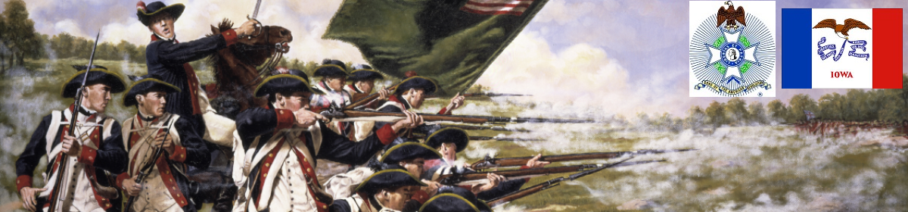

The Iowa Compatriot
The Journal of the Iowa Society, Sons of the American Revolution December 1, 2017

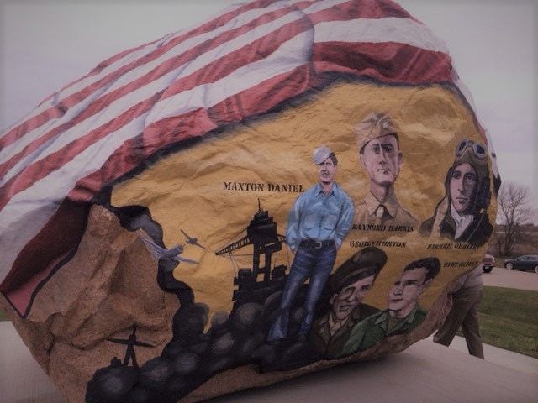

Clarke County Freedom Rock Dedicated

On the 11th hour of the 11th day of the 11th month nearly 500 people from around the country joined near the Clarke County Iowa town of Murray for the dedication of the Clarke County, Iowa Freedom rock painted by artist Ray "Bubba" Sorenson II.

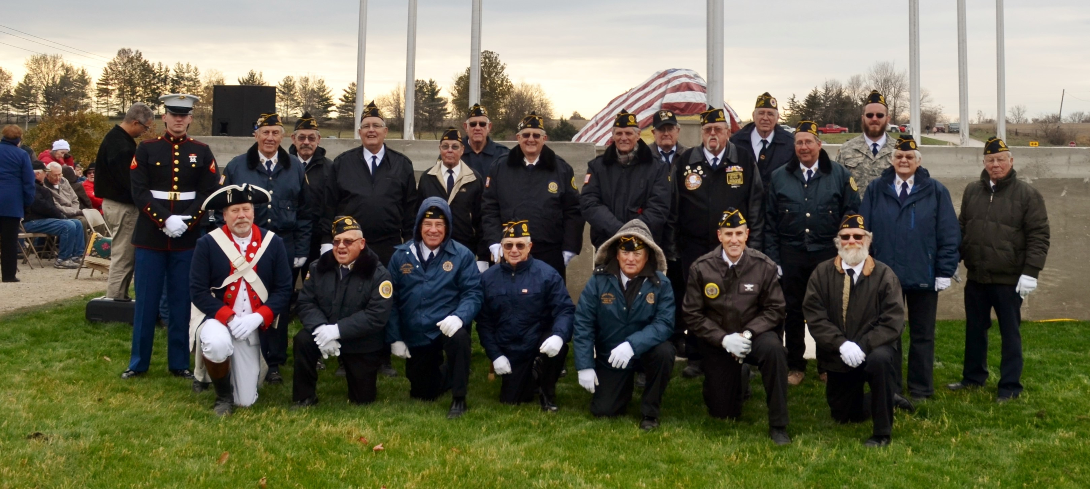

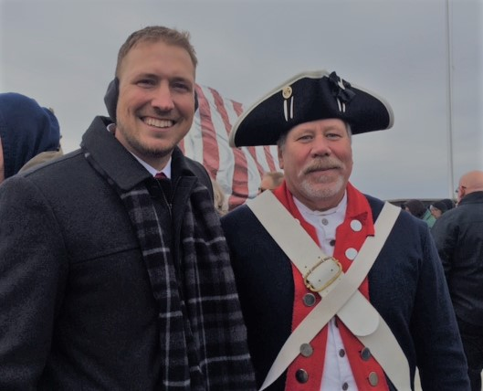
Among the attendees were color guard members of the American Legion, the Veteran of Foreign Wars and the Iowa Society of the Sons of the American Revolution.

Governor Reynolds gave a passionate speech on the sacrifices of the veterans and their families to preserve and protect the liberties of all. It was also noted that current members of the military account for only about 1% of the population.

Mr. Sorenson shared with those in attendance his vision for this Freedom Rock in particular as well as the individualization of all 68 Freedom Rocks done to date in Iowa.

contributed by Mike Rowley

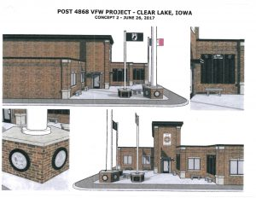
CLEAR LAKE — North-central Iowans honored veterans with several Veterans Day ceremonies around the area on Saturday. In Clear Lake, not only did they honor veterans with a luncheon, the Clear Lake VFW Post 4868 kicked off a $100-thousand capital campaign to fund a veterans memorial to be located in the courtyard of their downtown post. from KGLO website http://kglonews.com/campaign-kicked-off-to-raise-funds-for-clear-lake-veterans-memorial/

North Iowa Compatriot Daniel Thorson Contributes to Veterans Memorial Campaign

“Debi and I took my 1944 Willys MB over to the Clear Lake VFW (Post 4868) to help kick off fund raising for a new veteran's memorial.”

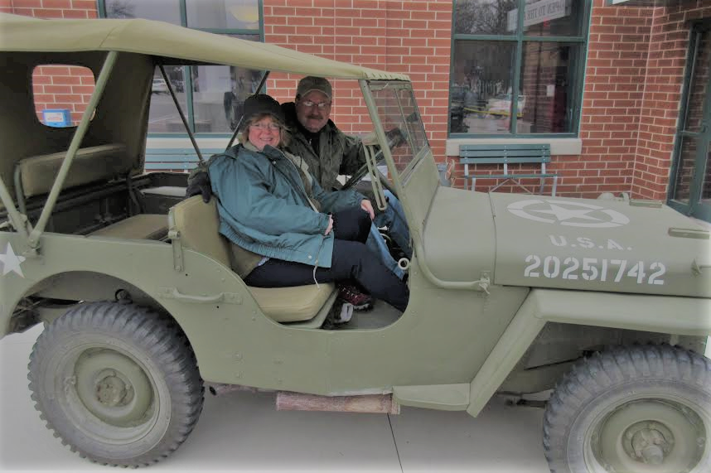

Compatriot Martin Visits New A. R. War Museum
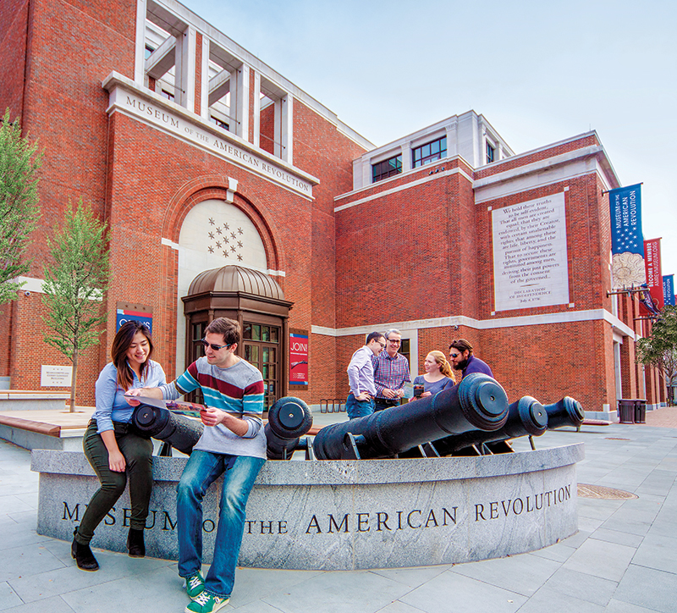
Dear Patriot Mike,

As a founding member, I finally got the chance to visit the new museum in Philly. It opens at 10:00 am and closes at 5pm. We were first in and last out, and read everything. We saw General Washington’s private tent. This is the Museum of the American Revolution, not the American Revolutionary War museum. There is a difference. Having never been there, I thought it was well worth the experience. Still lots of history to see and absorb. Nice book store also.

Richard Martin
NNSAR 167879

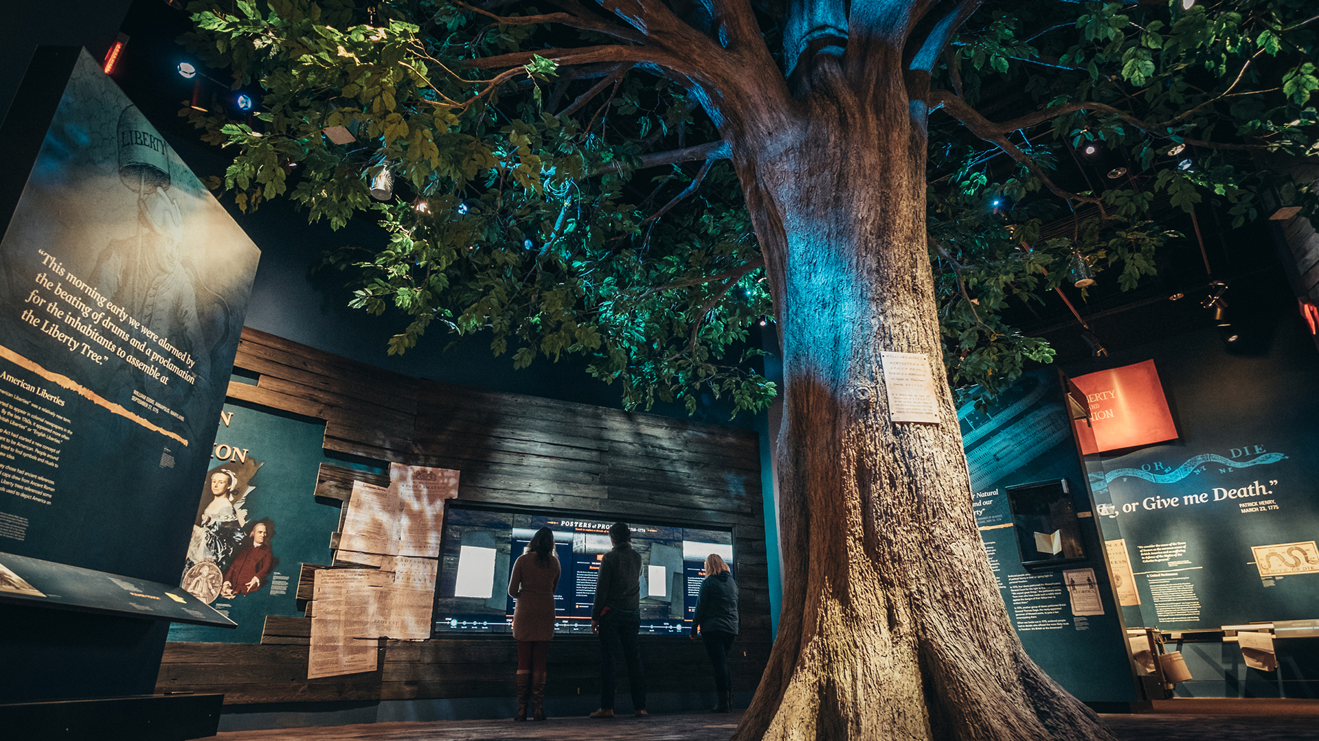

Reminder About Dues

Compatriots -- Thank you for paying your dues early and promptly. If you have not paid your 2018 dues, we are down to the last four weeks of the campaign. Here is a reminder for those that haven't paid their dues:

We hope you want to continue to be an active member with us. For a regular membership, the dues are $50. Make out a check today to Iowa Society S A R, and send it to:

George DeMoss, IASSAR Secretary/Treasurer, 814 SE Cortina Drive, Ankeny, IA 50021.

We do appreciate you being a part of the Iowa Society, SAR!

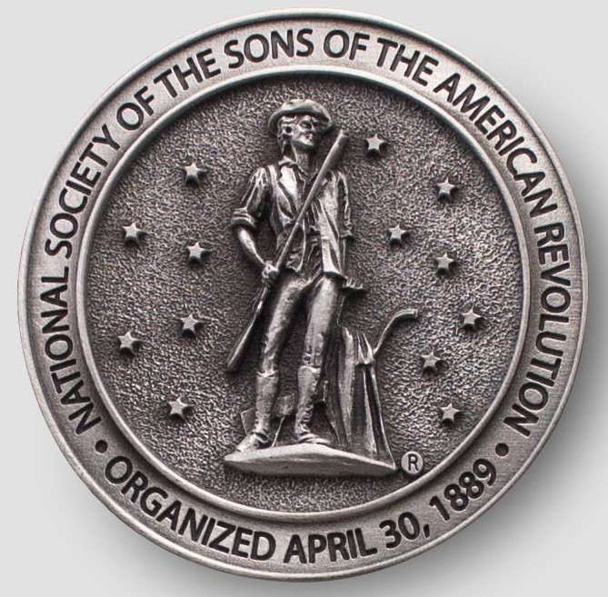

Have you looked at the IASSAR Website Lately? Stay up-to-date with all IASSAR activities. www.iassar.org

Contribute to The Iowa Compatriot!
This is your newsletter, covering all activities and programs of the IASSAR. To keep it alive and vibrant, we need you to contribute stories about SAR events happening in your part of the state. The stories need not be long. However, they do need to reflect the ideals of the SAR, and how our Iowa compatriots support them. Sharing what we do will help unify our membership. Please send your stories to me. We’d love to print your photos as well! My email address is dlfrazer@yahoo.com. If you would prefer to use the USPS to mail your news items and photos, address them to me at:

Doug Frazer
4410 Skyline Drive
Des Moines, IA 50310

Thanks. Hope to hear from you soon!
Doug Frazer, editor

Your IASSAR Board of Managers

President Alan Wenger awenger5@mchsi.com
1st V.P Mike Rowley MJR1825@gmail.com
2nd V.P. Kevin Parmenter mail@parmenter.com
Secretary George DeMoss Joanndmos@gmail.com
Treasurer George DeMoss Joanndmos@gmail.com
Acting Registrar Alan Wenger awenger5@mchsi.com
Chancellor Lance Ehmcke Lance.Ehmcke@heidmanlaw.com
Historian Doug Frazer dlfrazer@yahoo.com
Eagle Scout Chr. Doug Frazer dlfrazer@yahoo.com
Webmaster Patrick Lant iassarwebsite@gmail.com

