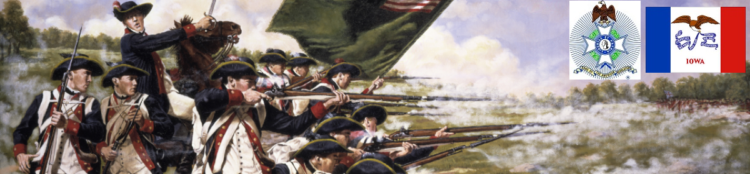

The Iowa Compatriot
The Journal of the Iowa Society, Sons of the American Revolution January 4, 2018

We the descendants of the heroes of the American Revolution, who by their sacrifice established the United States of America, reaffirm our faith in the principles of liberty and solemnly pledge to defend them against every foe.

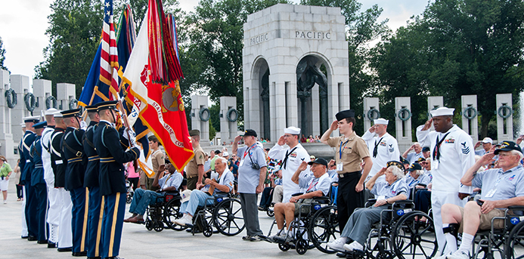

A
lady in her 70's walked quite a distance and up a hill to a member of our Color Guard, she asked if he had been the same person standing alone on the hill on Fleur Drive in Des Moines when the 17 bus loads of mostly Viet Nam and Korean War veteran were leaving for their Honor Flight to Washington D. C. He responded that he was.

The lady said that she was sure that Color Guard could not have seen it or known but she wanted me to pass the following information on to that individual. She was the helper escort for her husband, a Viet Nam veteran on the bus that day. She said when he and all of those on the entire bus saw the Color Guardsman in uniform saluting them on the hill that there was a thunderous cheer from all veterans and escorts alike. She said that the entire busload of veteran saluted and talked about it for quite some time after.

What a great reminder to our active members that what you do matters, even though you may not always see it.

contributed by Mike Rowley
Compatriot Blake Wilkinson and the Commemorative Tokens at Wreaths Across America

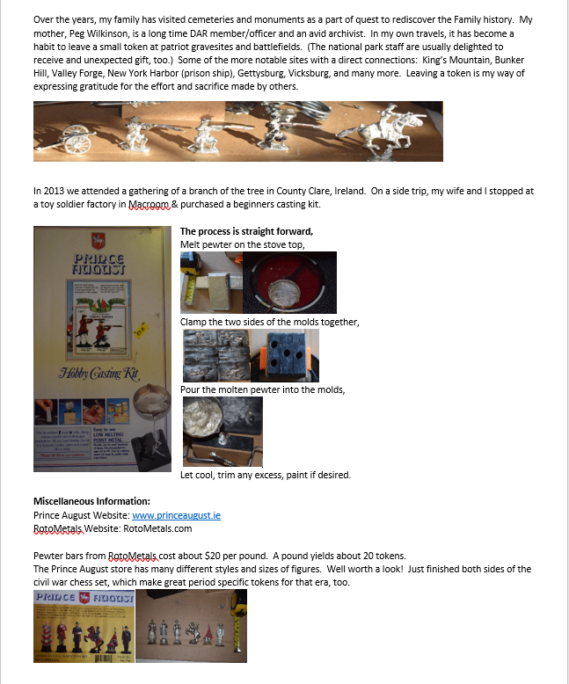
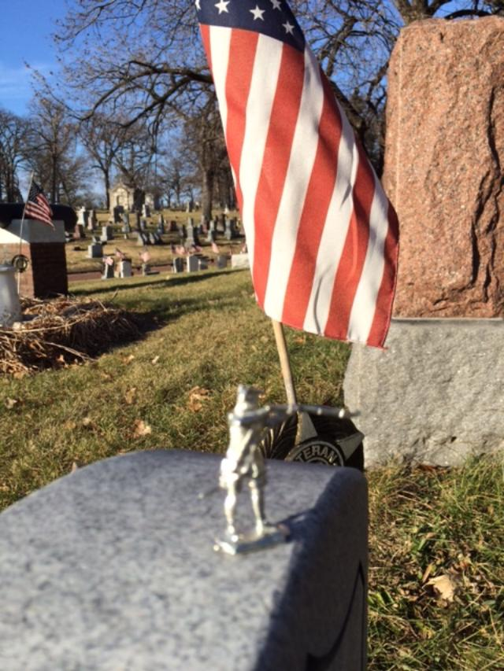
Compatriot Wilkinson sent me a few samples and when I attended the Wreaths Across America ceremony yesterday at the Iowa Veterans Cemetery in Van Meter. I watched some of the family members laying wreaths on their relatives’ graves.

I approached a grandfather and veteran with his grandson and asked if it would be all right if I gave the grandson one of the pewter soldiers as a token of thanks for his service.

The second pewter soldier was presented to a wheel chair bound young man that I have seen at the event for several years snow, cold or sunshine. Both were very grateful not only of the gift as a remembrance but also as a token of thanks for their service and their effort to remember those now passed.

The Wreaths across America Ceremony has grown every year, and the crowd numbered several hundred on this 51-degree Iowa "winter" day. Nearly 2800 wreaths were laid in this cemetery alone. Over 1400 cemeteries and over 1,500,000 wreaths were donated and laid across the country this year. IASSAR members participated for the 10th year in a row at the Wreaths Across America program at the Iowa Veterans Cemetery in Van Meter, Iowa. With the weather over 50 degrees this was by far the largest attended WAA ever at the IVC.

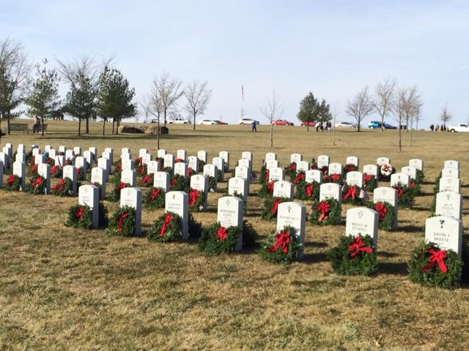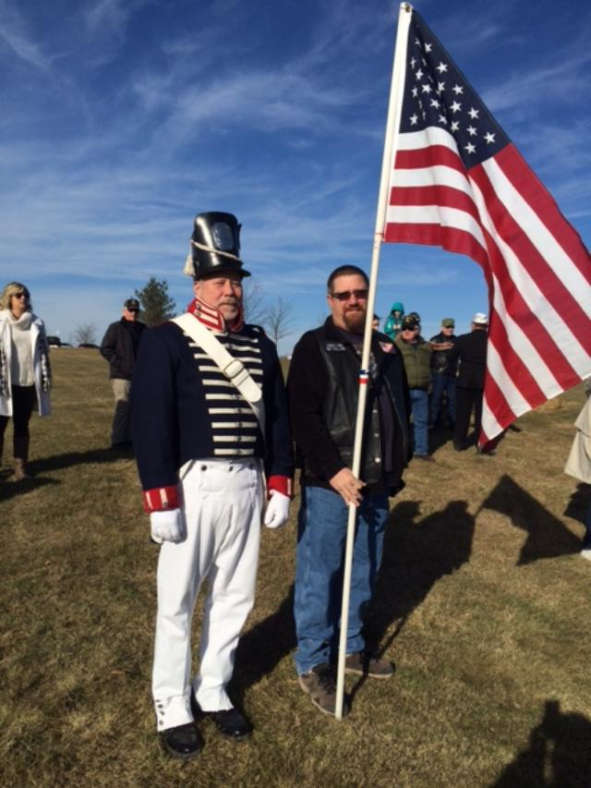
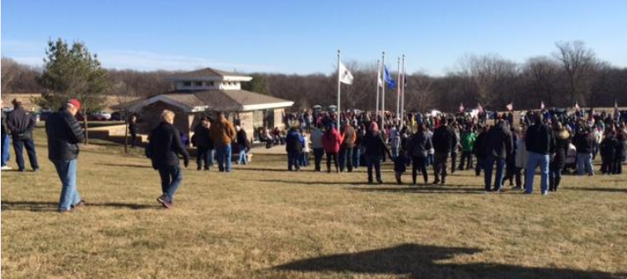
contributed by Mike Rowley

You Don’t Say!

I
have often found pleasure in attempting to research the origin of “sayings”. Especially those that impart (as most do) a bit of “folk wisdom”, social irony, or just good old “common sense”.

For example, a wonderful old Scottish maxim (perhaps especially applicable at this time of year when families are temporarily drawn back together by the celebrations of the season) offers the sage advice that, “Fish and Relatives take on a peculiarly displeasing odor after three-days.”

More truth than poetry there, eh?

Another bit of particularly American wisdom relates to an expression that has to do with the “assuming of airs”, by persons who might wish to impress others by giving the impression of their self-perceived superior social status. The saying, “putting on the dog(s)” has always struck me as being somewhat odd, until I came to understand that as the descendant of Colonial “Cordwainers” (makers of bespoke footwear) there was a logical explanation.

In Colonial America, there were two categories of tradesmen who dealt with footwear.

“Cobblers” were itinerant repairers of shoes and boots. In some colonies they were even restricted from establishing permanent shops as places of business and thus travelled the roads and streets offering their services.

“Cordwainers” were tradesmen who designed and made custom footwear for persons able to afford “better” shoes, boots, and slippers that were made to measure for their feet. For most Cobblers, theirs was more or less a hand to mouth operation; but, may Cordwainers appear to have done very well for themselves financially and amassed small fortunes in goods and properties.
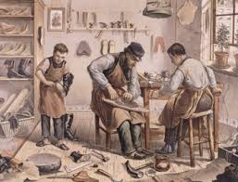
Cordwainers offered wide selections of leathers and fabrics to their customers who could afford to own more than one pair of shoes or boots. And, those who could indulge in the luxury of having special shoes of slippers made for dancing wanted the softest and most supple materials to allow for the flexion required by the dances of the times. One of the most popular materials for this purpose was the tanned leather of the skin of a canine.

Hence….”putting on the dog(s)” became a saying synonymous with exuberance and “high times” and came to be a somewhat pejorative expression in a society that was as yet more or less in recovery from the earlier puritanical beliefs of just a generation or two before.

-contributed by Compatriot David M. Lamb, descendant of Two Boston Cordwainers (Thomas and James Townsend)

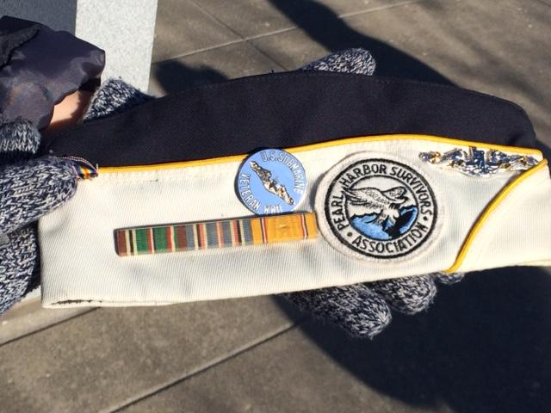

O
n December 7th, 76 years ago today Pearl Harbor was attacked. More than 2400 Americans were killed, and another 1000 were wounded.

Each year in Des Moines and many other locations around the country The Sons and Daughters of Pearl Harbor Survivors take time to remember and honor those service men and women and their families who gave some much on that day.

Again this year, members of the Iowa SAR, the Central Iowa Chapter and the IASSAR Color Guard joined with them to remember.
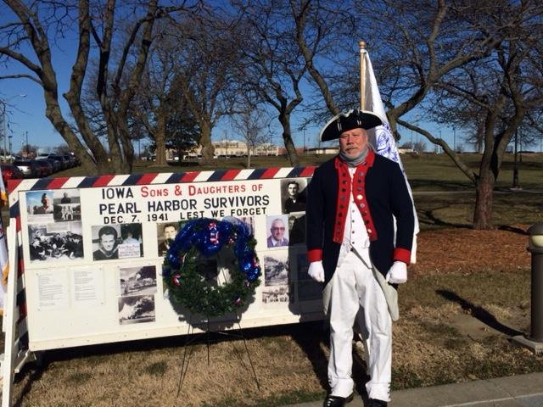

Respectfully,
Mike Rowley
#166348 Iowa SAR

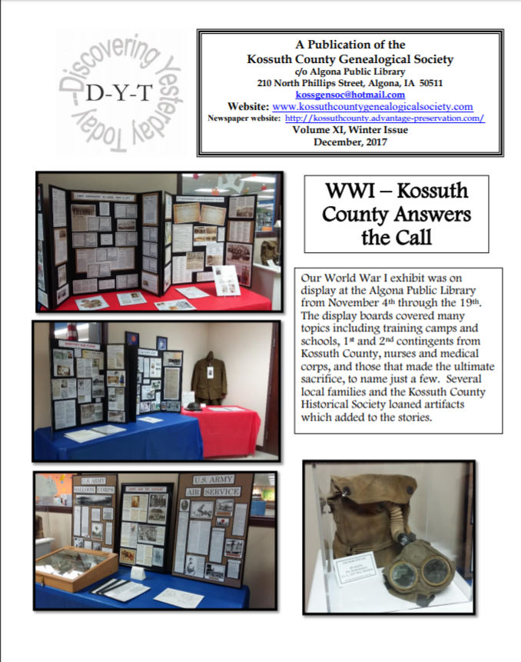


I just finished a new book by Bill O'Riley: Killing England, a story of the brutal struggle for American independence.

It is really an eye opener from the start of the war to the end. I would recommend reading it. It is an in-depth look at the Revolution.

Patrick Murray
SAR Nat'l #94310

In Memoriam

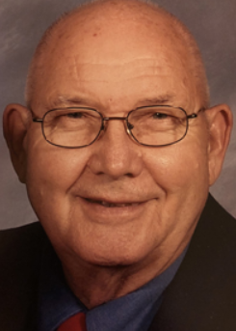

Compatriot Fran Keith, DDS. Fran was a past member, newsletter editor and very active member of the board of managers of the Iowa SAR for several years until declining health curbed his activities.

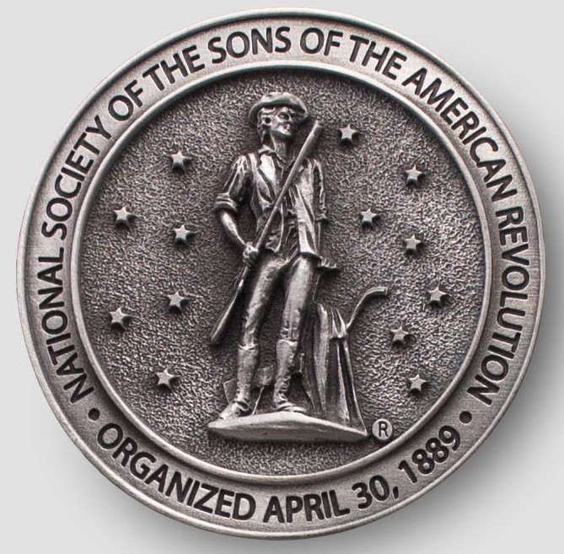

Have you looked at the IASSAR Website Lately? Stay up-to-date with all IASSAR activities. www.iassar.org

Contribute to The Iowa Compatriot!
This is your newsletter, covering all activities and programs of the IASSAR. To keep it alive and vibrant, we need you to contribute stories about SAR events happening in your part of the state. The stories need not be long. However, they do need to reflect the ideals of the SAR, and how our Iowa compatriots support them. Sharing what we do will help unify our membership. Please send your stories to me. We’d love to print your photos as well! My email address is dlfrazer@yahoo.com. If you would prefer to use the USPS to mail your news items and photos, address them to me at:

Doug Frazer, 4410 Skyline Drive, Des Moines, IA 50310

Your IASSAR Board of Managers

President Alan Wenger awenger5@mchsi.com
1st V.P Mike Rowley MJR1825@gmail.com
2nd V.P. Kevin Parmenter mail@parmenter.com
Secretary George DeMoss Joanndmos@gmail.com
Treasurer George DeMoss Joanndmos@gmail.com
Acting Registrar Alan Wenger awenger5@mchsi.com
Chancellor Lance Ehmcke Lance.Ehmcke@heidmanlaw.com
Historian Doug Frazer dlfrazer@yahoo.com
Eagle Scout Chr. Doug Frazer dlfrazer@yahoo.com
Webmaster Patrick Lant iassarwebsite@gmail.com

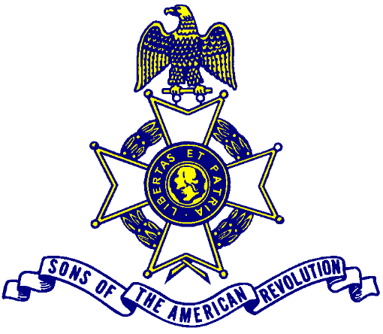

Let us remember our obligation to our forefathers, who gave us our Constitution,
The Bill of Rights, an independent Supreme Court and a nation of free men.

