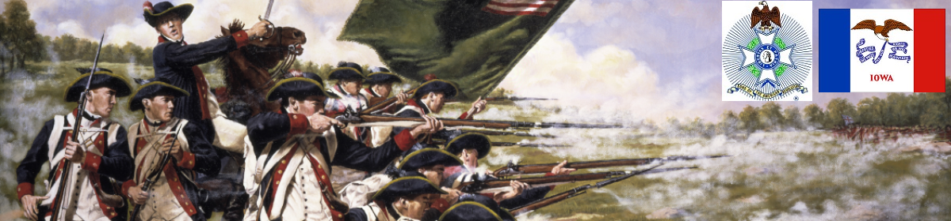

The Iowa Compatriot
The Journal of the Iowa Society, Sons of the American Revolution November 1, 2017

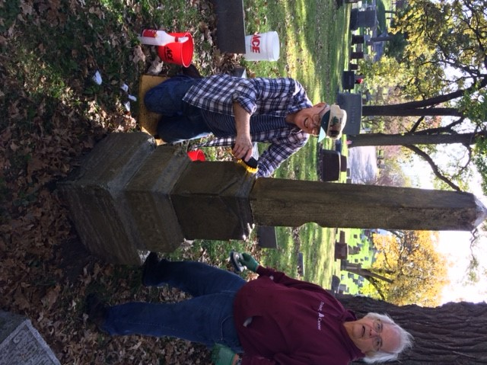
DeMoss Sets High Standard for Volunteerism

"There just don’t seem to be enough hours in a day." While many of us may feel that way at times. Iowa Sons of the American Revolution member, secretary and treasurer George DeMoss seems to almost manufacture hours with his many volunteer efforts.

On a recent week this fall, George was again seen volunteering for the Des Moines Parks and Recreation Department, which oversees the care of our capital city cemeteries. The latest of many projects involved scrubbing of gravestones in historic Woodland Cemetery. The often-neglected stones that adorn the graves of those from past centuries and families long removed are now seen overgrown with moss and other debris.

Shortly before taking a short break for lunch George was overheard asking a younger volunteer, "How are you holding up?" With living examples of the volunteer spirit of members like Compatriot DeMoss how could others not be impressed?

Photo Left to right- IASSAR member George DeMoss (kneeling plaid shirt) and another volunteer at Woodland Cemetery in Des Moines, October 19, 2017. Photo by Mike Rowley

Alas
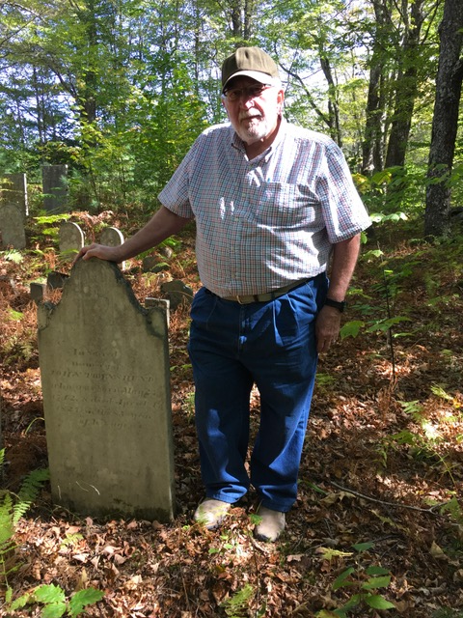
by IASSAR Veterans Committee Chairman David Lamb

In nearby Bolton, Massachusetts, are the graves of his father Joshua Townsend, two of John’s biological brothers (Richard and Robert) and three of his nephews who also marched to Concord and Cambridge with him in the early morning hours of April 19th, 1775. Joshua was in his seventy-fifth year on the night of, “The Lexington Alarm”, but he shouldered his musket and gamely marched beside his sons and grandsons to face the King’s Grenadiers. Three generations of Townsend’s stood shoulder to shoulder that next day. Through some Divine Providence, all would survive the seven long and arduous years to come.

It is my deep regret that my own life’s journeys have not brought me here sooner, to pay my respects to men and boys to whom I owe my very existence, and to whom this nation owes the freedoms that have blessed this land for eight generations. To stand among the graves of better men than myself, was an honor that I had neglected for far too long.

So far as I know, I am the first of my lineage to return here since John died in 1827, in the 85th year of his life. I had much to convey unto to him of the nearly two centuries that separate us.

For myself, I could only report to him that his male descendants of my own line had tried to do our duties as he set before us with his own; and, have continued to fight in every one of our conflicts since his war that separated us from a foreign tyrant and made us a nation. I could tell him with pride that we had attempted to pass the torch of liberty and freedom that he and his men set alight from each successive generation to the next that has passed through this world from his day to ours. But alas, I could not tell him that, “The shot heard around the world” that he was present to hear, had not been followed by the roar of cannon at Gettysburg, at San Juan Hill, Belieu Wood, Tarawa, Bastogne, and Pork Chop Hill…or as small arms fire in the jungles of Vietnam, the deserts of Iraq and Afghanistan, and at schoolhouses at Columbine, Newtown, and a fairground in Las Vegas.

I wish that I might have been able to tell him that the right to own and bear arms that he and his brethren secured for us had not been perverted into a means of killing innocent children, or people enjoying an evening of music on our city streets.

I wish that I could have told him that we had not squandered what he bequeathed to us, and that we had built a better world than this…..but alas.

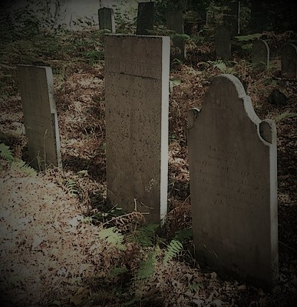

O
n a week ending with heavy rains and constant clouds the sky opened up with seemingly Divine intervention long enough for the Color Guard of the General Society of the War of 1812 in the State of Iowa to join with citizens, guests, and active members of the Des Moines Park and Recreation Department to perform the sacred duties of retiring nearly 2700 un-serviceable American flags.
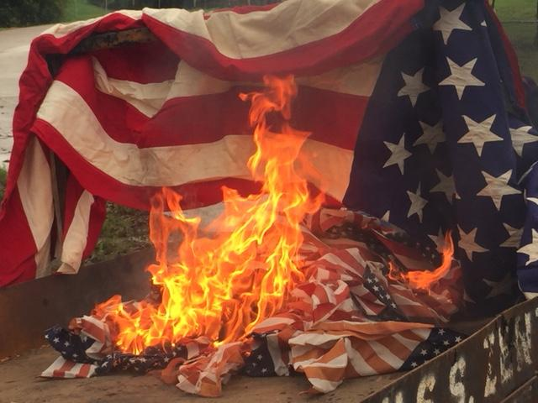
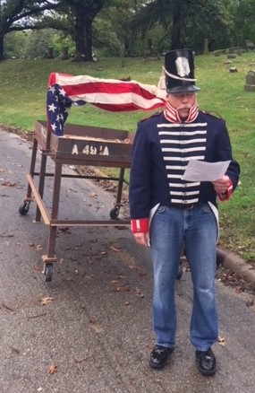
Utilizing the materials built by GSW 1812 Iowa Past President Louie Zenti and a special forged tool, hand made by a veteran in Michigan and supplied by Ganesh Ganpat; GSW 1812 Iowa President Mike Rowley (left) open the ceremony with borrowed passages from the Sons of Union Veterans of the Civil War when he stated,

"We have presented here these flags of our country which have been inspected and condemned as un-serviceable. They have reached their present state in a proper service of tribute, memory and love.

A flag may be a flimsy bit of printed gauze, or a beautiful banner of the finest silk. Its intrinsic value may be trifling or great: but its real value is beyond price, for it is a precious symbol that our dear country stands for; a free nation of free men and women, true to the faith of the past, and devoted to the ideals and practice of Justice, Freedom and Democracy.

It represents all that our brothers and sisters and our nation's defenders in all conflicts lived for, sacrificed for and died for.

Let these faded flags of our country be retired and destroyed with respectful and honorable rites and their places taken by bright new flags of the same size and kind, and let no grave of our soldier, sailor or airmen and women dead be unhonored and unmarked.

Special thanks to Hannah Champeau, Field Coordinator, and Ganesh Ganpat, Supervisor, Des Moines Park and Recreation for their assistance without which the program would not have been possible.

~submitted by Mike Rowley

Compatriots Honored at Fall Iowa SAR Meeeting

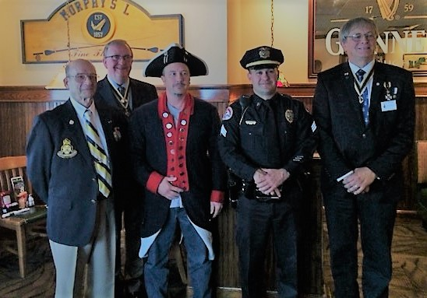

Iowa Society of the Sons of the American Revolution Past Presidents Harold Goodrich and Lance Ehmke, newest IASSAR member Jason Corder, Urbandale Police Sgt. Chad Underwood who was presented the S.A.R. Law Enforcement Commendation Medal in recognition of outstanding Achievement and dedication to the maintenance of law and order, and current IASSAR President Alan Wenger

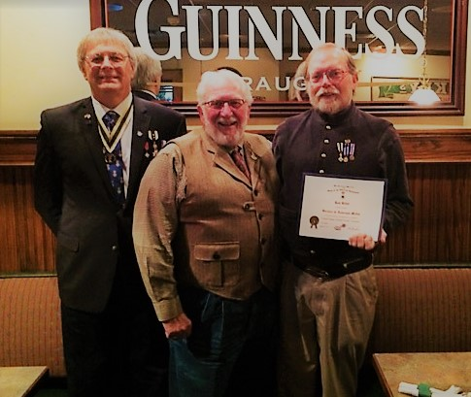

Iowa Society of the Sons of the American Revolution President Alan Wenger, IASSAR Veterans Committee Chairman David Lamb and Service to Veterans Medal awardee Ron Rittel

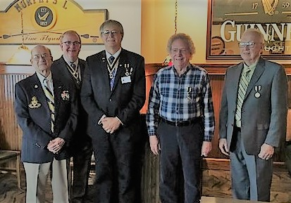

Iowa Sons of the American Revolution past Presidents Harold Goodrich and Lance Ehmke, Current IASSAR President Alan Wenger, Color Guard Badge Awardee Jon Verner and Service to Veterans awardee George DeMoss

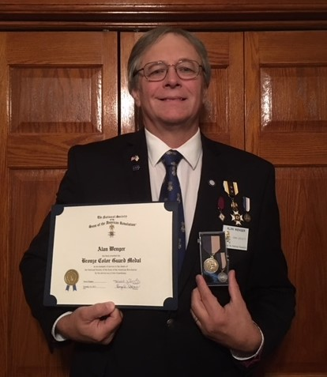

The Bronze Color Guard Medal and Certificate was awarded to Iowa Society of the Sons of the American Revolution President Alan Wenger
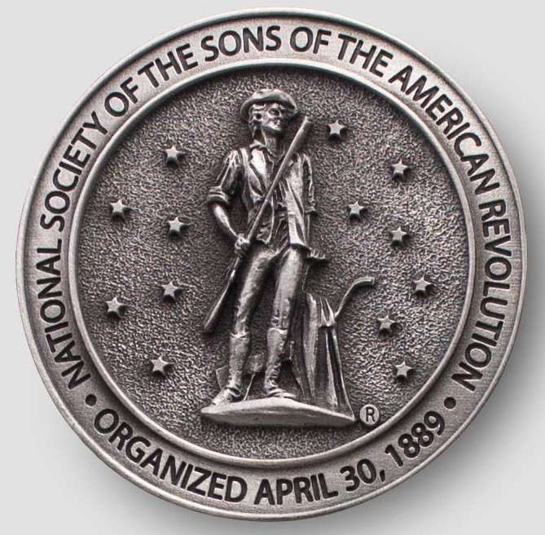

Have you looked at the IASSAR Website Lately? Stay up-to-date with all IASSAR activities. www.iassar.org

Contribute to The Iowa Compatriot!
This is your newsletter, covering all activities and programs of the IASSAR. To keep it alive and vibrant, we need you to contribute stories about SAR events happening in your part of the state. The stories need not be long. However, they do need to reflect the ideals of the SAR, and how our Iowa compatriots support them. Sharing what we do will help unify our membership. Please send your stories to me. We’d love to print your photos as well! My email address is dlfrazer@yahoo.com. If you would prefer to use the USPS to mail your news items and photos, address them to me at:

Doug Frazer
4410 Skyline Drive
Des Moines, IA 50310

Thanks. Hope to hear from you soon!
Doug Frazer, editor

Your IASSAR Board of Managers

President Alan Wenger awenger5@mchsi.com
1st V.P Mike Rowley MJR1825@gmail.com
2nd V.P. Kevin Parmenter mail@parmenter.com
Secretary George DeMoss Joanndmos@gmail.com
Treasurer George DeMoss Joanndmos@gmail.com
Acting Registrar Alan Wenger awenger5@mchsi.com
Chancellor Lance Ehmcke Lance.Ehmcke@heidmanlaw.com
Historian Doug Frazer dlfrazer@yahoo.com
Eagle Scout Chr. Doug Frazer dlfrazer@yahoo.com
Webmaster Patrick Lant iassarwebsite@gmail.com

