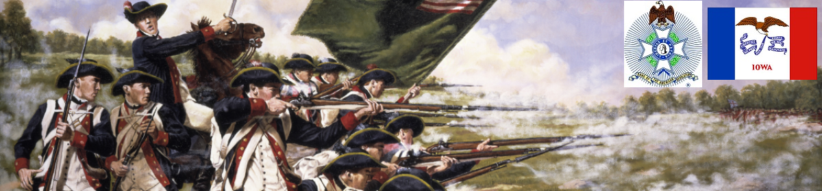

The Iowa Compatriot
The Journal of the Iowa Society, Sons of the American Revolution May 1, 2017

Rowley Recounts SAR Contributions at Proclamation Signing

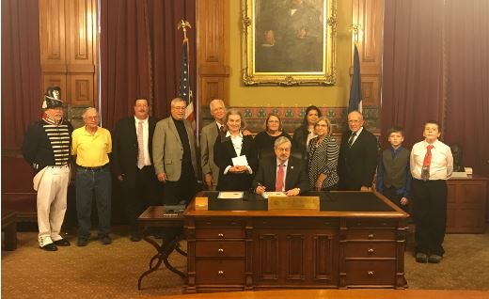
Iowa SAR Vice President Mike Rowley joined with members of the State Association for the Preservation of Iowa Cemeteries (SAPIC) at the signing of a proclamation by Iowa Governor and United States Ambassador to China nominee Terry Branstad on March 30, 2017. Compatriot Rowley shared with the governor the fact that members of the Iowa groups have documented nearly 900 veterans of the War of 1812 that are buried in the State of Iowa.
Iowa’s ROTC/JROTC Programs Show 100% Participation

Mike Rowley, the ROTC/JROTC Awards Chairman of the Iowa Society of the Sons of the American Revolution reports that The Iowa Society has completed another year of 100% participation from all the ROTC/JROTC programs in the entire State of Iowa.

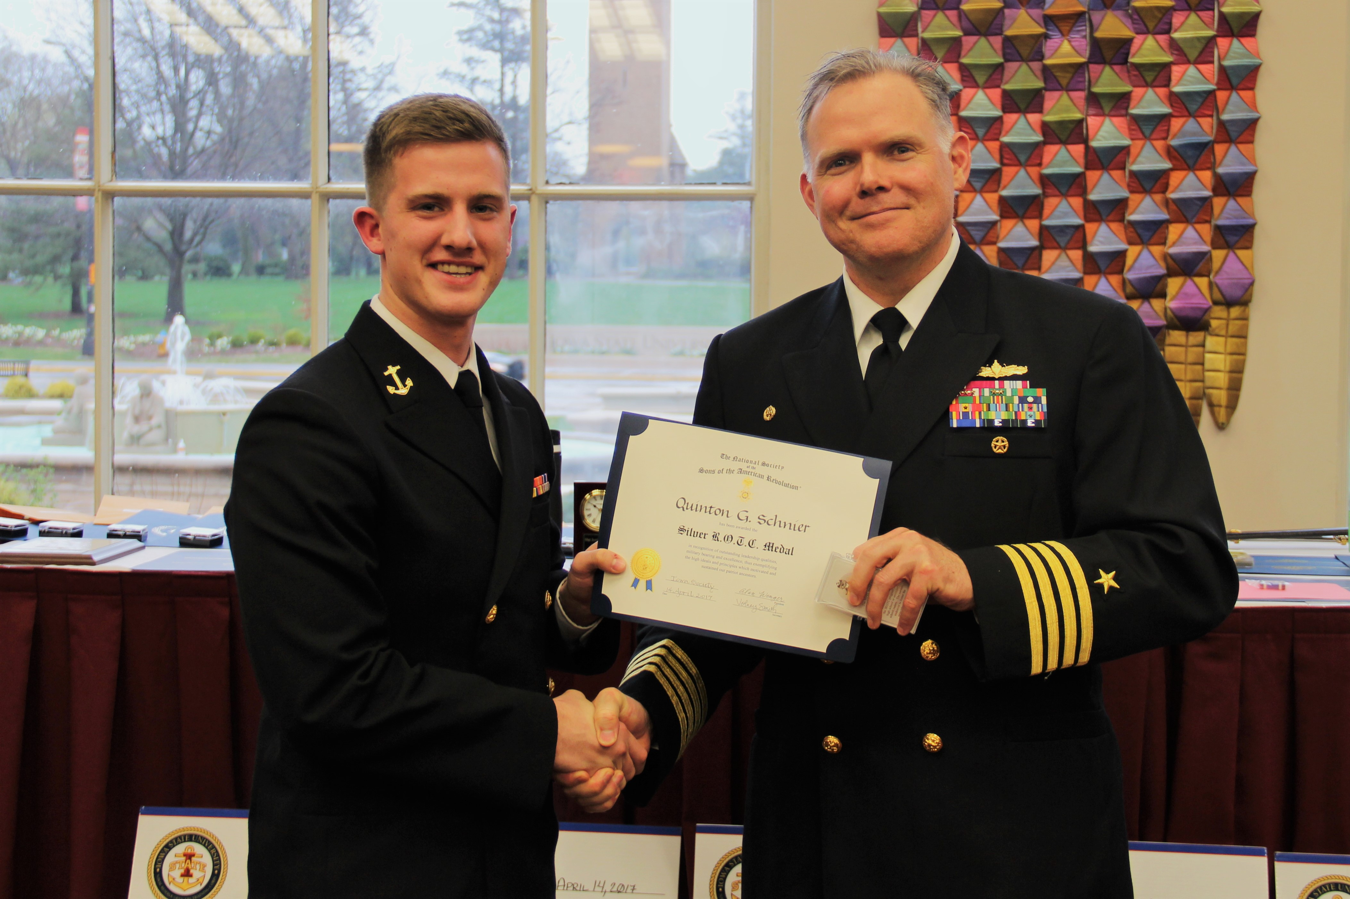
The Iowa State University Navy ROTC awards banquet held April 14, 2017. The recipient of the NSSAR Silver ROTC Medal for leadership excellence and military bearing is MIDN 3/C Quinton G. Schnier. The presenter is Capt. Scott Curtis, the commanding officer of the NROTC unit at Iowa State University. (photo by Capt. Suzanne Mulet)

Why I am a member of the SAR

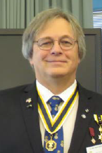
Why am I a member of the SAR? I’ll be honest…it first started out as kind of a “reward” to myself for all the genealogy work I had done over a 30-year period. I figured if I could “connect all the dots”, it would validate my efforts against, what at times, seemed to be insurmountable odds. It then became more of a legacy…something to leave my children and grandchildren. As time went on, I discovered all the great things the SAR had to offer. Community service, aiding our veterans, recognition of officials who have distinguished themselves in their communities, both SAR members and non-members, and recognition of our youth in the Eagle Scout and ROTC programs. Also, promoting the CAR (Children of the American Revolution) for they are our future. And, my favorite…the recognition of our patriot ancestors, to honor them, and to make sure their final resting places are restored, maintained and recorded.
One of my sons has taken up the mantle…to continue on with the genealogy. He, too, may one day become a member of the SAR. My wife is a member of the Daughters of the American Revolution (DAR) and, as I write this, I am also working on getting my granddaughters into the CAR. Long story short…I do this for my descendants. I want them to know that I once belonged to great organization that deemed it necessary to maintain our history so they could read and learn about it, and feel pride in our efforts.

Alan Wenger

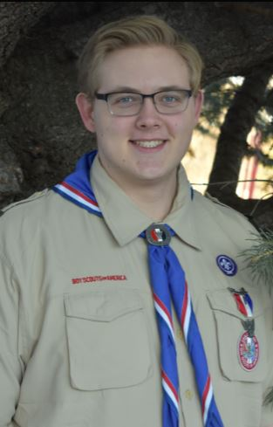
Wegge Wins 3rd Place
in NSSAR Eagle Scout Award
Iowan Everett Daniel Wegge, Eagle Scout from Troop 66 in Decorah, won third place in the Arthur M. and Berdena King Eagle Scout Award competition, placing ahead of 36 other contestants from 10 state societies. NSSAR Eagle Scout Committee Vice Chair David J. Perkins informed Dave Shannon, past IASSAR Eagle Scout Chairman, of Wegge’s winning entry in early March. Wegge will receive a $4,000 college scholarship.

Note the Date

May 10 and/or 12: Volunteers to raise veteran's stones at Glendale Cemetery in Des Moines in preparation for Memorial Day.

May 17: SAR ancestry workshop at Nationwide Insurance, Des Moines

May 27: The director of Poweshiek County Veterans Affairs has asked for representatives of the S.A.R, Sons of Union Veterans of the Civil War, and the General Society of the War of 1812 to participate in the recognition of a War of 1812 veteran buried in Brooklyn, IA, and the dedication of his newly placed grave marker.

May 29 (Memorial Day): The Iowa Gold Star Museum at Camp Dodge, Des Moines, is also asking for representatives, in costume, to participate in their Memorial Day event.

As the flowers rest on the decorated graves and the sunlight shines on the beautiful sailboats, Uncle Sam whispers in my ear about how we should care for the soldiers and remember the ones that have died. Swimming pools open, BBQs fry. Today is the day to think of what they have done for us. There are blurs of red, white and blue marching down the street and flags are lowered at half-mast. But we should always remember and never forget what set us free, from this very day on.
--Ali M., 3rd Grader, Academy Elementary School, Madison, Connecticut

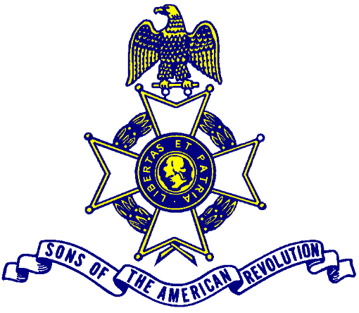

New Iowa SAR Directory Needs Your Current Email Address
We are way overdue for publishing an Iowa SAR directory. We hope to publish one this spring so it is extremely important that members submit their CURRENT EMAIL ADDRESS ASAP before publication. Please submit yours to 1st V.P. Mike Rowley at mjr1825@gmail.com
Thank you!

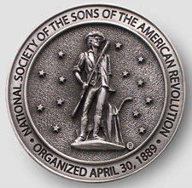
Why Are YOU a Member of the IASSAR?
Please reflect on this question, and write us! We will publish it in the next Iowa Compatriot! dlfrazer@yahoo.com

Wanted! More SAR members!
Compatriots! We urgently need to add more members to the SAR, plain and simple. You can help. Please talk with people, and promote our organization and what we stand for. Please pass on this newsletter to them. An SAR application is included with this newsletter. Questions? Contact Mike Rowley, MJR1825@gmail.com

Have You Viewed the IASSAR Website?
Stay up-to-date with all IASSAR activities. Kudos to webmaster Patrick Lant for maintaining an excellent site. www.iassar.org

If You Visit a Patriotic Site While on Vacation. . .
Please let your fellow compatriots know about it! Send a short description of where you went, and (if possible) include a picture of you at the site. dlfrazer@yahoo.com

Contribute to The Iowa Compatriot!
This is your newsletter, covering all activities and programs of the IASSAR. To keep it alive and vibrant, we need you to contribute stories about SAR events happening in your part of the state. The stories need not be long. However, they do need to reflect the ideals of the SAR, and how our Iowa compatriots support them. Sharing what we do will help unify our membership. Please send your stories to me. We’d love to print your photos as well! My email address is dlfrazer@yahoo.com. If you would prefer to use the USPS to mail your news items and photos, address them to me at:

Doug Frazer
4410 Skyline Drive
Des Moines, IA 50310

Thanks. Hope to hear from you soon!
Doug Frazer, editor

Guide to the IASSAR Papers at the University of Iowa
The University of Iowa Library - Special Collections holds an assortment of pamphlets and papers of the IASSAR, spanning the dates 1926-1961. A guide to the holdings is printed below. We will be contacting the library staff to see if the library would agree to accept donations of other historical records now in our possession. Thanks to Mike Rowley for this information.

Collection Overview
Date Span: | 1926-1961
Creator: | Iowa Society of the Sons of the American Revolution
Extent: | .25 linear feet.
Collection Number: | MSC0266
Repository: | University of Iowa Special Collections
Summary: | Records of the Sons of the American Revolution, Iowa Society, 1937-1956. 12 items. Secretary's notebook, a history of the organization in Iowa, printed pamphlets, and one copy of the society's publication, The Old Continental.
Access: This collection is open for research.
Use: Copyright restrictions may apply; please consult Special Collections staff for further information.
Acquisition:
Preferred Citation: Iowa Society of the Sons of the American Revolution Papers, The University of Iowa Libraries, Iowa City, Iowa.
Repository: | University of Iowa Special Collections
Address: | Special Collections Department  University of Iowa Libraries  Iowa City, IA 52242
Phone: | 319-335-5921
Curator: | Greg Prickman
Email: | lib-spec@uiowa.edu
Website: | http://www.lib.uiowa.edu/sc
Browse by Series:
Series 1: GENERAL
- Series 1: GENERAL
· Box 1:
- Secretary's notebook - 1937-1940
- Scrapbook of biographies and genealogies, #1022 -- 1182
- Tinkham, Edwin P. "A History of the Iowa Society Sons of the American Revolution: The Objects of the Iowa Society, With Quotations: Sketches of Past and Present Leaders" - 1935
- "Officers, Constitution, By-Laws, Membership" - 1930
pamphlet, 2 copies
- Mutz, Sterling F., comp. "National Society, Sons of the American Revolution, Washington, D.C.," undated
pamphlet, 2 copies
- "National Society Sons of the American Revolution, fifth edition" - 1948
pamphlet
- "National Society Sons of the American Revolution, seventh edition" - 1951
pamphlet
- "Handbook, Second edition, National Society of the Sons of the American Revolution" - 1961
pamphlet
- "National Charter, Constitution and By-Laws" - 1926
pamphlet
- "National Charter, Constitution and By-Laws" - 1936, 1939
pamphlet, 1936 edition annotated to 1939
- "National Charter, Constitution and By-Laws" - 1936, 1948
pamphlet, 1936 edition annotated to 1948
- "The Old Continental," Bulletin of the Iowa Society Sons of the American Revolution. v.30, no.1, May 19 - 1956
- "The Old Continental," Bulletin of the Iowa Society Sons of the American Revolution. v.12, no.3, September - 1934
- "The Old Continental," Bulletin of the Iowa Society Sons of the American Revolution. v.9, no.2, September - 1930
- Xerox copy of the application for membership to the Pennsylvania Society of the Sons of the American Revolution of Herbert Hoover, approved November 7 - 1928

Your IASSAR State Officers

President Alan Wenger awenger5@mchsi.com
1st V.P Mike Rowley MJR1825@gmail.com
2nd V.P. Kevin Parmenter mail@parmenter.com
Secretary Volney Smith VHSmith@q.com
Treasurer Volney Smith VHSmith@q.com
Registrar John Butler JB22630@yahoo.com
Chancellor Lance Ehmke Lance.Ehmke@Heidmanlaw.com
Historian Doug Frazer dlfrazer@yahoo.com
Eagle Scout Chr. Doug Frazer dlfrazer@yahoo.com
Webmaster Patrick Lant iassarwebsite@gmail.com

