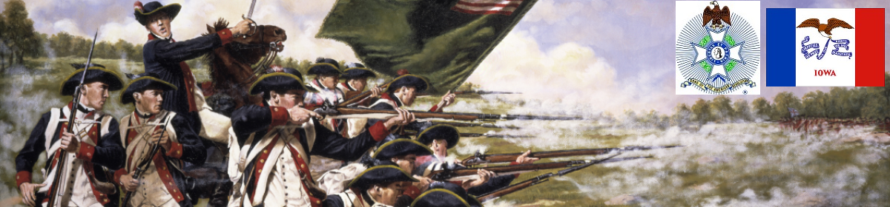

The Iowa Compatriot
The Journal of the Iowa Society, Sons of the American Revolution March 1, 2018

We the descendants of the heroes of the American Revolution, who by their sacrifice established the United States of America, reaffirm our faith in the principles of liberty and solemnly pledge to defend them against every foe.

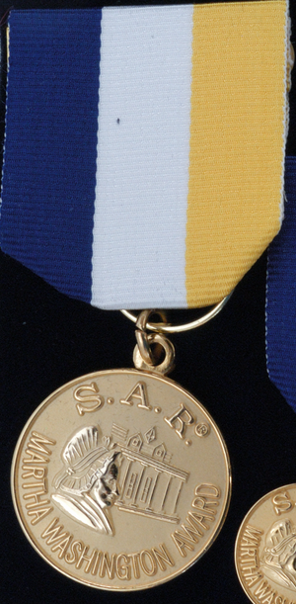
BOM Awards Martha Washington Medal to ISDAR Registrar Jodi Ann Freet

The Iowa SAR Board of Managers approved Jodi Ann Freet, ISDAR State Registrar 2016-2018, ISCAR Senior State Registrar 2016-2018 for the Martha Washington Medal.

The Iowa Society of the Sons of the American Revolution is proud of our working relationships with the D.A.R. and C.A.R., and we are grateful for the many potential applicants that both of these organizations send our way.

Recently Jodi Ann Freet was instrumental in assisting in the approval of 3 new members, Alan, Mark and Ronald Hughes. What makes these 3 new S.A.R. members unique is that they were the first in the history of the Iowa Society to establish membership through a female Patriot of the American Revolution.

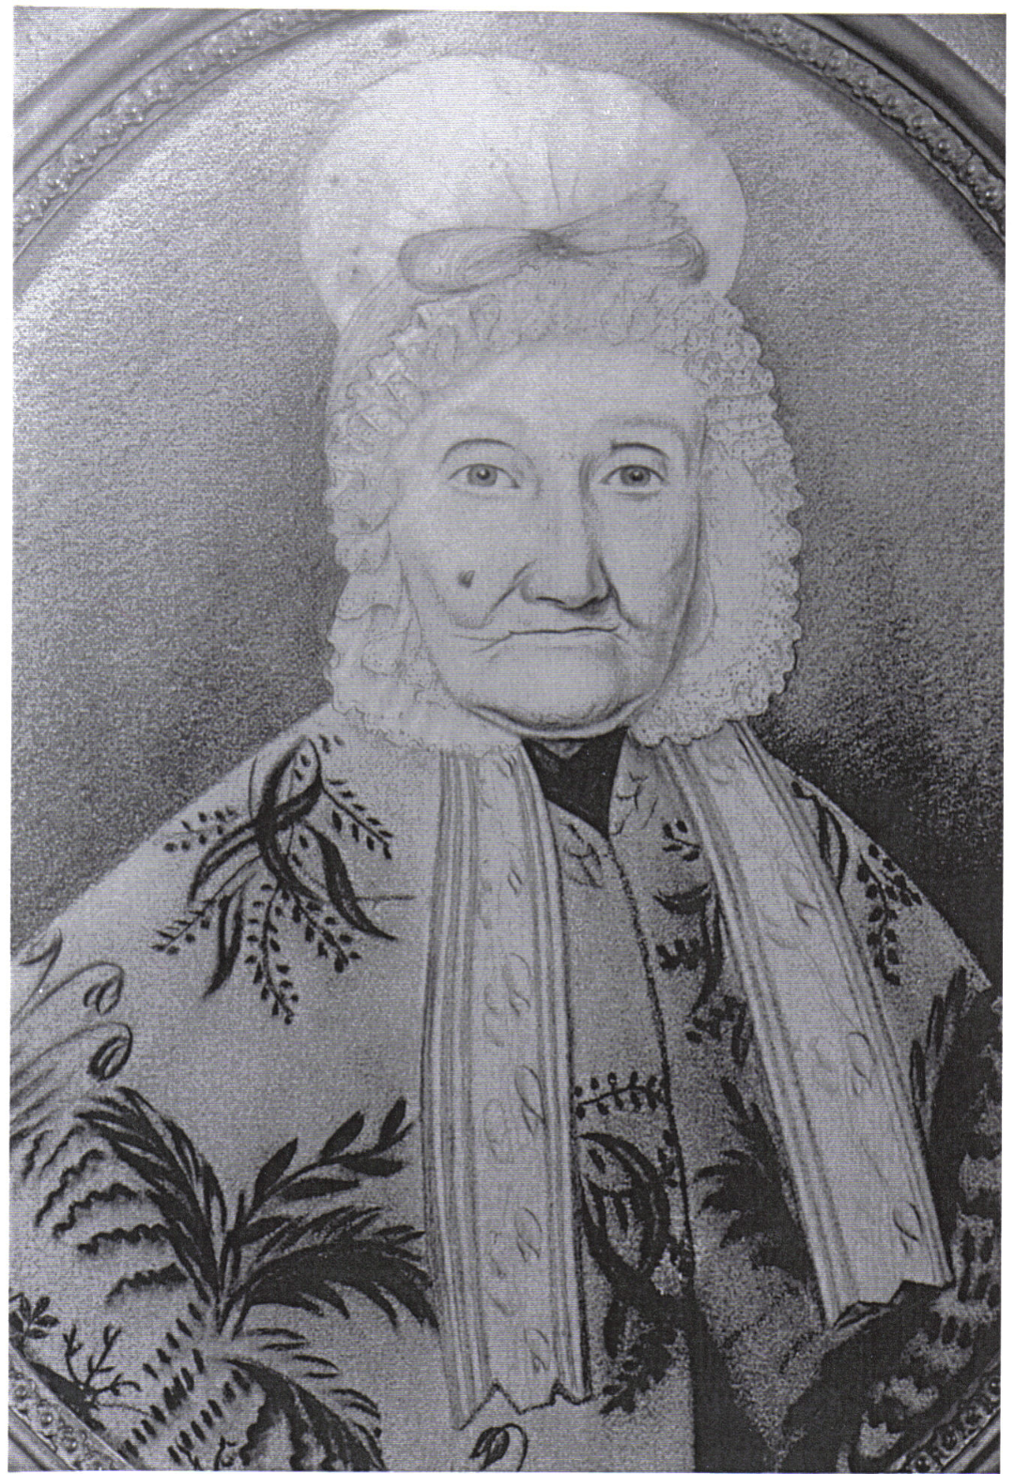
This story of Mary (Polly) Hawkins Craig (pictured) is found on Wikipedia, quoting from historians’ writings:

Bryan Station was located a short distance from a spring that the camp used for drinking water.

Since the hostiles secretly surrounding the fort did not realize that the presence of their large force was known by the defenders, the men allowed the women to exit the fort to retrieve water and other resources. The reason this was done was in order to prevent any change in habit that could signal that the defenders were aware of the presence of the hidden force preparing to besiege them.

. . . All the important contemporary writers convey this impression: "For the men to go to the spring would be to do exactly as the native desired and devote the garrison to destruction. If the women went in accordance with their regular early morning custom, the enemy would be confirmed in the delusion that their presence in force was undiscovered, and would withhold their fire to insure the complete success of their plans. The suggestion was full of hope. . .

This was done with the knowledge that two years earlier Ruddell's and Martin's Stations had seen the death of several, including women and children. So, the bravery of the women of Bryan Station is all the greater.

That Patriot was Mary (Polly) Hawkins
The Martha Washington Medal symbolizes Jodi’s life of service and many contributions.

Jodi became a member of DAR in February 2007, joining as a Junior member of the Cedar Falls Chapter. She became active in her chapter very quickly, and was elected to the position of Chapter Treasurer in 2008, holding that position until she was elected Chapter Regent in 2012. Her first appointment at the State Level was in July 2010, when she was named ISDAR Junior Membership Co-Chair. In 2012, She was named ISDAR Junior Membership Chair and held that position until 2014. In 2014, Jodi was elected to the position of ISDAR State Recording Secretary, and held that office until 2016, when she was elected ISDAR State Registrar.

She is currently serving the Iowa Society as both State Registrar and as State Chair of the Public Relations and Media Committee. She is also a member of ISDAR’s Action 5/Chapter Revitalization and Development Committee and a member of the Lineage Research Committee.

Jodi was named Iowa’s Outstanding Junior in 2011, and was the first member of the Cedar Falls Chapter to have been given that honor.

Jodi Freet has served as an Iowa Society DAR page for six years, paged at Continental Congress six years, and she has volunteered to page in the states of Michigan, Connecticut and New York. When she paged in New York in 2014, she was awarded that state’s Outstanding Page Award.

In addition to DAR, Jodi is an active member of the United States Daughters of 1812 (currently serving as State Recording Secretary); Continental Society Daughters of Indian Wars (currently serving as State Governor); National Society Dames of the Court of Honor (currently serving as State President). Jodi also belongs to New England Women, National Society Daughters of Colonial Wars and the Descendants of the Founders of Ancient Windsor.

The IASSAR congratulates Jodi Ann Freet on this honor, and looks forward to continued partnerships with the D.A.R and C.A.R.

Respectfully submitted by Mike Rowley, 1st VP IASSAR Awards Chairman

DMACC-Newton Campus Receives Flag Recognition

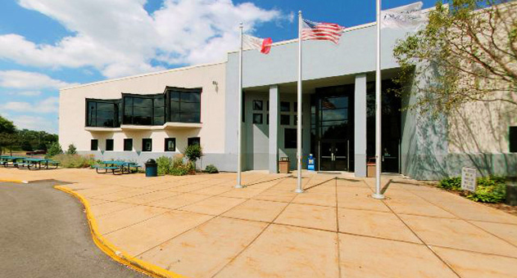

The Newton Campus of Des Moines Area Community has received SAR recognition for properly displaying and caring for the American flag. Since its founding in fall 1993, DMACC-Newton has become a vital educational resource for Jasper County and central Iowa. The flags of the United States, the State of Iowa, and City of Newton are flown prominently outside the main building. When the American flags become worn and tattered due to weather, they are donated to local Boy Scout troops for proper disposal. The IASSAR commends DMACC-Newton for demonstrating true patriotism.

Any Compatriot can nominate and recognize an individual or organization for this honor. Contact Doug Frazer for certificates. dlfrazer@yahoo.com

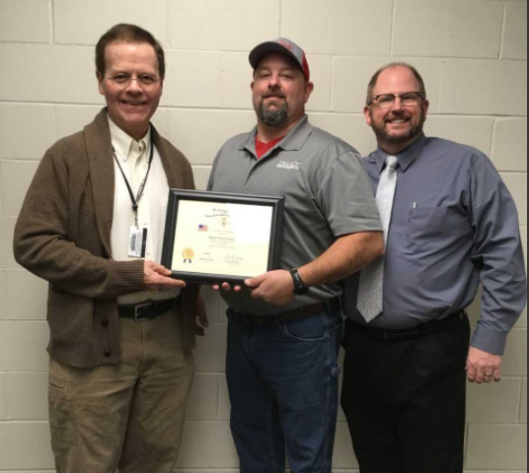

IASSAR member Doug Frazer presents the SAR Flag Certificate to DMACC-Newton officials Jason Chance, Building & Grounds Supervisor, and Dr. Joe DeHart, Provost.

Did you know? from The Atlantic magazine, Civil War Issue, February 2012

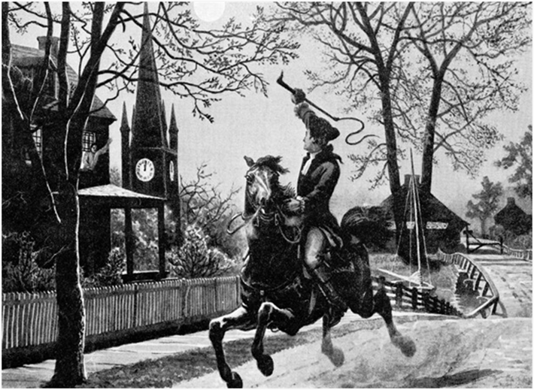

Henry Wadsworth Longfellow’s most popular work has been passed down through the generations as the quintessential Revolutionary War poem. But in fact it was the rift over slavery that Longfellow had in mind as he wrote the classic story of Paul Revere.

Longfellow was a committed abolitionist who had been quietly donating money toward buying the freedom of slaves. The day John Brown was hanged in 1859, the poet observed in his diary, “This will be a great day in our history, the date of a new Revolution quite as much needed as the old one.”

With “Paul Revere’s Ride,” he sought to create a patriotic national myth that would remind readers of their shared heroic past while galvanizing them to once more stand up for the nation’s founding principles. His poem didn’t exactly match the historic record—for example, Paul Revere was intercepted by the British before he got to Concord—but Longfellow was less concerned with being accurate than with fashioning a stirring common history.

On December 20, 1860, the day South Carolina seceded from the Union, the January 1861 issue of The Atlantic came out, featuring Longfellow’s poem.
—Sage Stossel

Paul Revere’s Ride
https://www.poets.org/poetsorg/poem/paul-reveres-ride

Listen, my children, and you shall hear
Of the midnight ride of Paul Revere,
On the eighteenth of April, in Seventy-Five:
Hardly a man is now alive
Who remembers that famous day and year.

He said to his friend, “If the British march
By land or sea from the town to-night,
Hang a lantern aloft in the belfry-arch
Of the North-Church-tower, as a signal-light,--
One if by land, and two if by sea;
And I on the opposite shore will be,
Ready to ride and spread the alarm
Through every Middlesex village and farm,
For the country-folk to be up and to arm.”

Then he said “Good night!” and with muffled oar
Silently rowed to the Charlestown shore,
Just as the moon rose over the bay,
Where swinging wide at her moorings lay
The Somerset, British man-of-war:
A phantom ship, with each mast and spar
Across the moon, like a prison-bar,
And a huge black hulk, that was magnified
By its own reflection in the tide.

Meanwhile, his friend, through alley and street
Wanders and watches with eager ears,
Till in the silence around him he hears
The muster of men at the barrack door,
The sound of arms, and the tramp of feet,
And the measured tread of the grenadiers
Marching down to their boats on the shore.

Then he climbed to the tower of the church,
Up the wooden stairs, with stealthy tread,
To the belfry-chamber overhead,
And startled the pigeons from their perch
On the sombre rafters, that round him made
Masses and moving shapes of shade,--
By the trembling ladder, steep and tall,
To the highest window in the wall,
Where he paused to listen and look down
A moment on the roofs of the town,
And the moonlight flowing over all.

Beneath, in the churchyard, lay the dead,
In their night-encampment on the hill,
Wrapped in silence so deep and still
That he could hear, like a sentinel’s tread,
The watchful night-wind, as it went
Creeping along from tent to tent,
And seeming to whisper, “All is well!”
A moment only he feels the spell
Of the place and the hour, and the secret dread
Of the lonely belfry and the dead;
For suddenly all his thoughts are bent
On a shadowy something far away,
Where the river widens to meet the bay, --
A line of black, that bends and floats
On the rising tide, like a bridge of boats.

Meanwhile, impatient to mount and ride,
Booted and spurred, with a heavy stride,
On the opposite shore walked Paul Revere.
Now he patted his horse’s side,
Now gazed on the landscape far and near,
Then impetuous stamped the earth,
And turned and tightened his saddle-girth;
But mostly he watched with eager search
The belfry-tower of the old North Church,
As it rose above the graves on the hill,
Lonely and spectral and sombre and still.
And lo! as he looks, on the belfry’s height,
A glimmer, and then a gleam of light!
He springs to the saddle, the bridle he turns,
But lingers and gazes, till full on his sight
A second lamp in the belfry burns!

A hurry of hoofs in a village-street,
A shape in the moonlight, a bulk in the dark,
And beneath from the pebbles, in passing, a spark
Struck out by a steed that flies fearless and fleet:
That was all! And yet, through the gloom and the light,
The fate of a nation was riding that night;
And the spark struck out by that steed, in his flight,
Kindled the land into flame with its heat.

He has left the village and mounted the steep,
And beneath him, tranquil and broad and deep,
Is the Mystic, meeting the ocean tides;
And under the alders, that skirt its edge,
Now soft on the sand, now loud on the ledge,
Is heard the tramp of his steed as he rides.

It was twelve by the village clock
When he crossed the bridge into Medford town.
He heard the crowing of the cock,
And the barking of the farmer’s dog,
And felt the damp of the river-fog,
That rises when the sun goes down.

It was one by the village clock,
When he galloped into Lexington.
He saw the gilded weathercock
Swim in the moonlight as he passed,
And the meeting-house windows, blank and bare,
Gaze at him with a spectral glare,
As if they already stood aghast
At the bloody work they would look upon.

It was two by the village clock,
When be came to the bridge in Concord town.
He heard the bleating of the flock,
And the twitter of birds among the trees,
And felt the breath of the morning breeze
Blowing over the meadows brown.
And one was safe and asleep in his bed
Who at the bridge would be first to fall,
Who that day would be lying dead,
Pierced by a British musket-ball.

You know the rest. In the books you have read,
How the British Regulars fired and fled,--
How the farmers gave them ball for ball,
From behind each fence and farmyard-wall,
Chasing the red-coats down the lane,
Then crossing the fields to emerge again
Under the trees at the turn of the road,
And only pausing to fire and load.

So through the night rode Paul Revere;
And so through the night went his cry of alarm
To every Middlesex village and farm,--
A cry of defiance, and not of fear,
A voice in the darkness, a knock at the door,
And a word that shall echo forevermore!
For, borne on the night-wind of the Past,
Through all our history, to the last,
In the hour of darkness and peril and need,
The people will waken and listen to hear
The hurrying hoof-beats of that steed,
And the midnight message of Paul Revere.

Have you looked at the IASSAR Website Lately? Stay up-to-date with all IASSAR activities. www.iassar.org

Contribute to The Iowa Compatriot!
This is your newsletter, covering all activities and programs of the IASSAR. To keep it alive and vibrant, we need you to contribute stories about SAR events happening in your part of the state. The stories need not be long. However, they do need to reflect the ideals of the SAR, and how our Iowa compatriots support them. Sharing what we do will help unify our membership. Please send your stories to me. We’d love to print your photos as well! My email address is dlfrazer@yahoo.com. If you would prefer to use the USPS to mail your news items and photos, address them to me at:

Doug Frazer, 4410 Skyline Drive, Des Moines, IA 50310

Your IASSAR Board of Managers

President Alan Wenger awenger5@mchsi.com
1st V.P Mike Rowley MJR1825@gmail.com
2nd V.P. Kevin Parmenter mail@parmenter.com
Secretary George DeMoss geodemoss62@gmail.com
Treasurer George DeMoss geodemoss62@gmail.com
Acting Registrar Alan Wenger awenger5@mchsi.com
Chancellor Lance Ehmcke Lance.Ehmcke@heidmanlaw.com
Historian Doug Frazer dlfrazer@yahoo.com
Eagle Scout Chr. Doug Frazer dlfrazer@yahoo.com
Webmaster Patrick Lant iassarwebsite@gmail.com

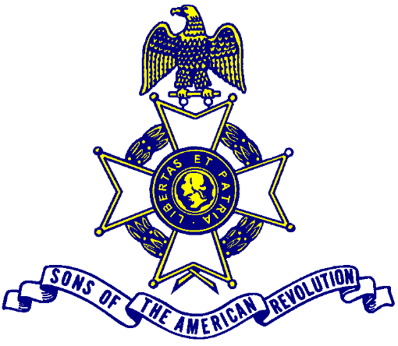

Let us remember our obligation to our forefathers, who gave us our Constitution,
The Bill of Rights, an independent Supreme Court and a nation of free men.

